

**PRACTICAL JOURNAL**

Enrollment Number – 2019BTCS088 Year of Enrollment – 2019-2023

Name of the Student – YASH GUPTA

School of COMPUTER SCIENCE & INFORMATION TECHNOLOGY

Program – B. TECH

Specialization/ Branch – CS&IT

Semester – 4TH Section – B2 Branch – CS&IT

Paper Code – BTCS03CCB5 Name of Paper – Statistics-II

Faculty-In-Charge – DVENENDRA CHOUHAN SIR

CERTIFICATE

THE PRACTICAL EXPERIMENTS

ENTERED IN THIS JOURNAL HAVE BEEN SATISFACTORY PERFORMED BY

ENROLLMENT NO - 2019BTCS088 MR/MS­­­­­­­­­­­­­­­­­­­­ YASH GUPTA

STUDYING IN PROGRAM B. TECH BRANCH CS&IT IN

SCHOOL OF COMPUTER SCIENCE & INFORMATION TECHNOLOGY

DURING SEMESTER 4TH OF ACADEMIC YEAR 2020-2021

_______________________

( )

Date: _________________

INDEX

|  |  |  |  |  |
| --- | --- | --- | --- | --- |
| S.NO | Title of Skill Activity | Date of Allocation | Date of Submission | Sign of Faculty |
| 1. | Median for 3 types of Series | 15/06/2021 | 16/06/2021 |  |
|  |  |  |  |  |
| 2. | Mode for 3 types of Series | 15/06/2021 | 16/06/2021 |  |
|  |  |  |  |  |
| 3. | Harmonic Mean for 3 types of Series | 15/06/2021 | 16/06/2021 |  |
|  |  |  |  |  |
| 4. | Geometric Mean for 3 types of Series | 15/06/2021 | 25/06/2021 |  |
|  |  |  |  |  |
| 5. | Arithmetic Mean for 3 types of Series | 15/06/2021 | 25/06/2021 |  |
|  |  |  |  |  |
|  |  |  |  |  |
|  |  |  |  |  |
|  |  |  |  |  |
|  |  |  |  |  |
|  |  |  |  |  |
|  |  |  |  |  |
|  |  |  |  |  |
|  |  |  |  |  |
|  |  |  |  |  |
|  |  |  |  |  |
|  |  |  |  |  |
|  |  |  |  |  |
|  |  |  |  |  |
|  |  |  |  |  |
|  |  |  |  |  |
|  |  |  |  |  |

Practical No: 01  
(Median for all 3 types of Series)  
  
 Date: 15th June 2021  
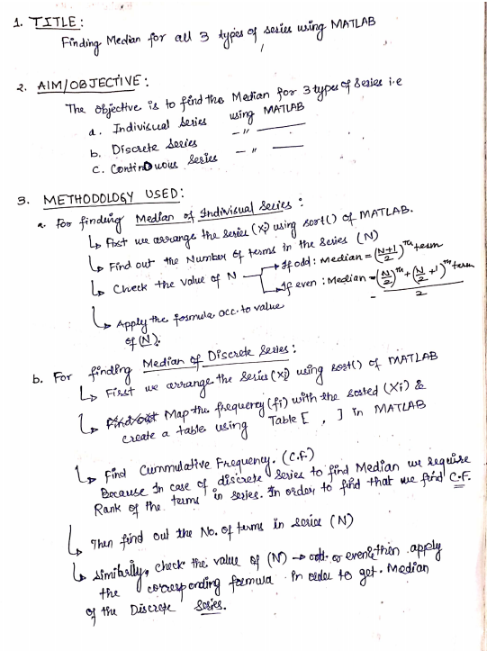

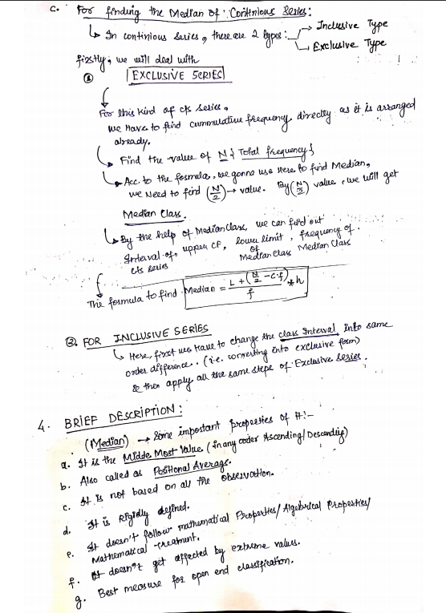

1. **MATLAB CODE:**
2. **Example 1: Median for Individual Series.**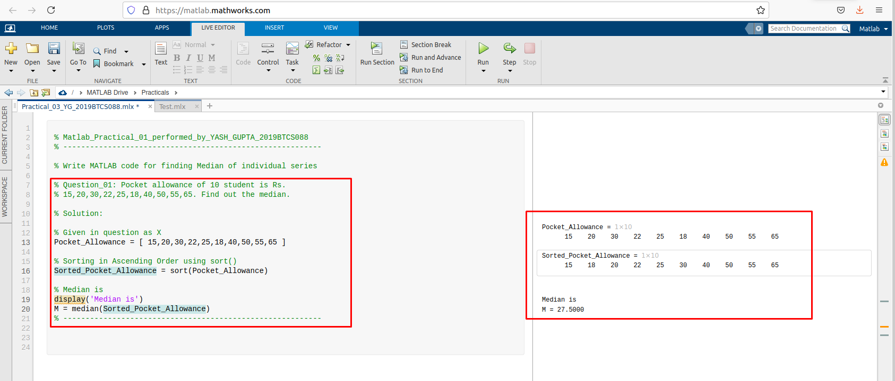
3. **Example 2: Median for Individual Series.**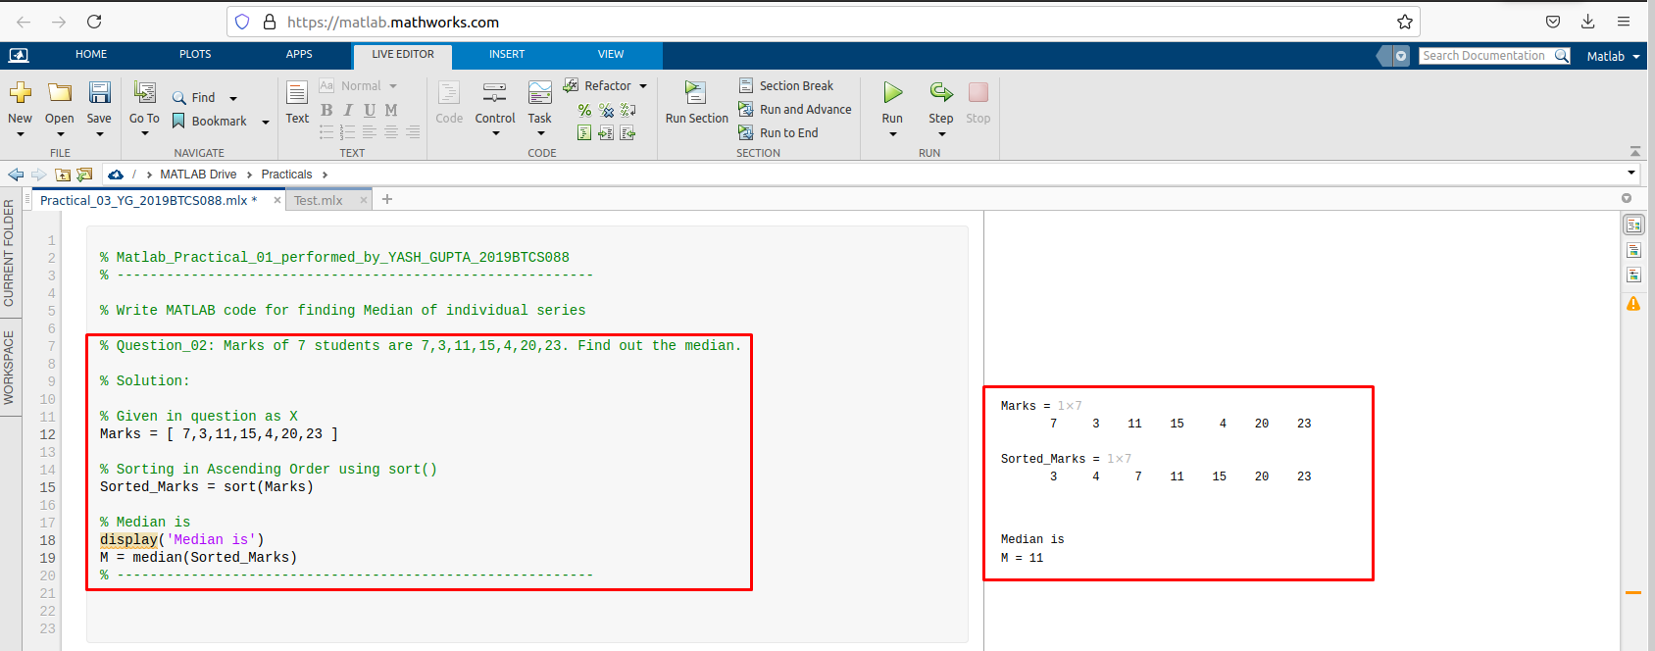
4. **Example 3: Median for Individual Series.**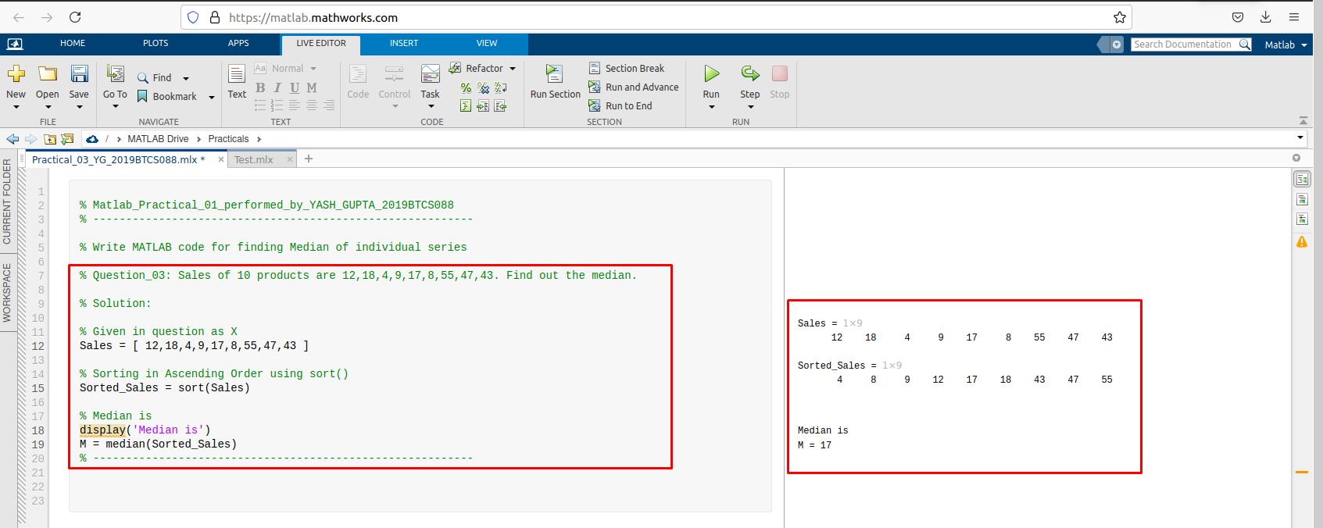
5. **Example 1: Median for Discrete Series.**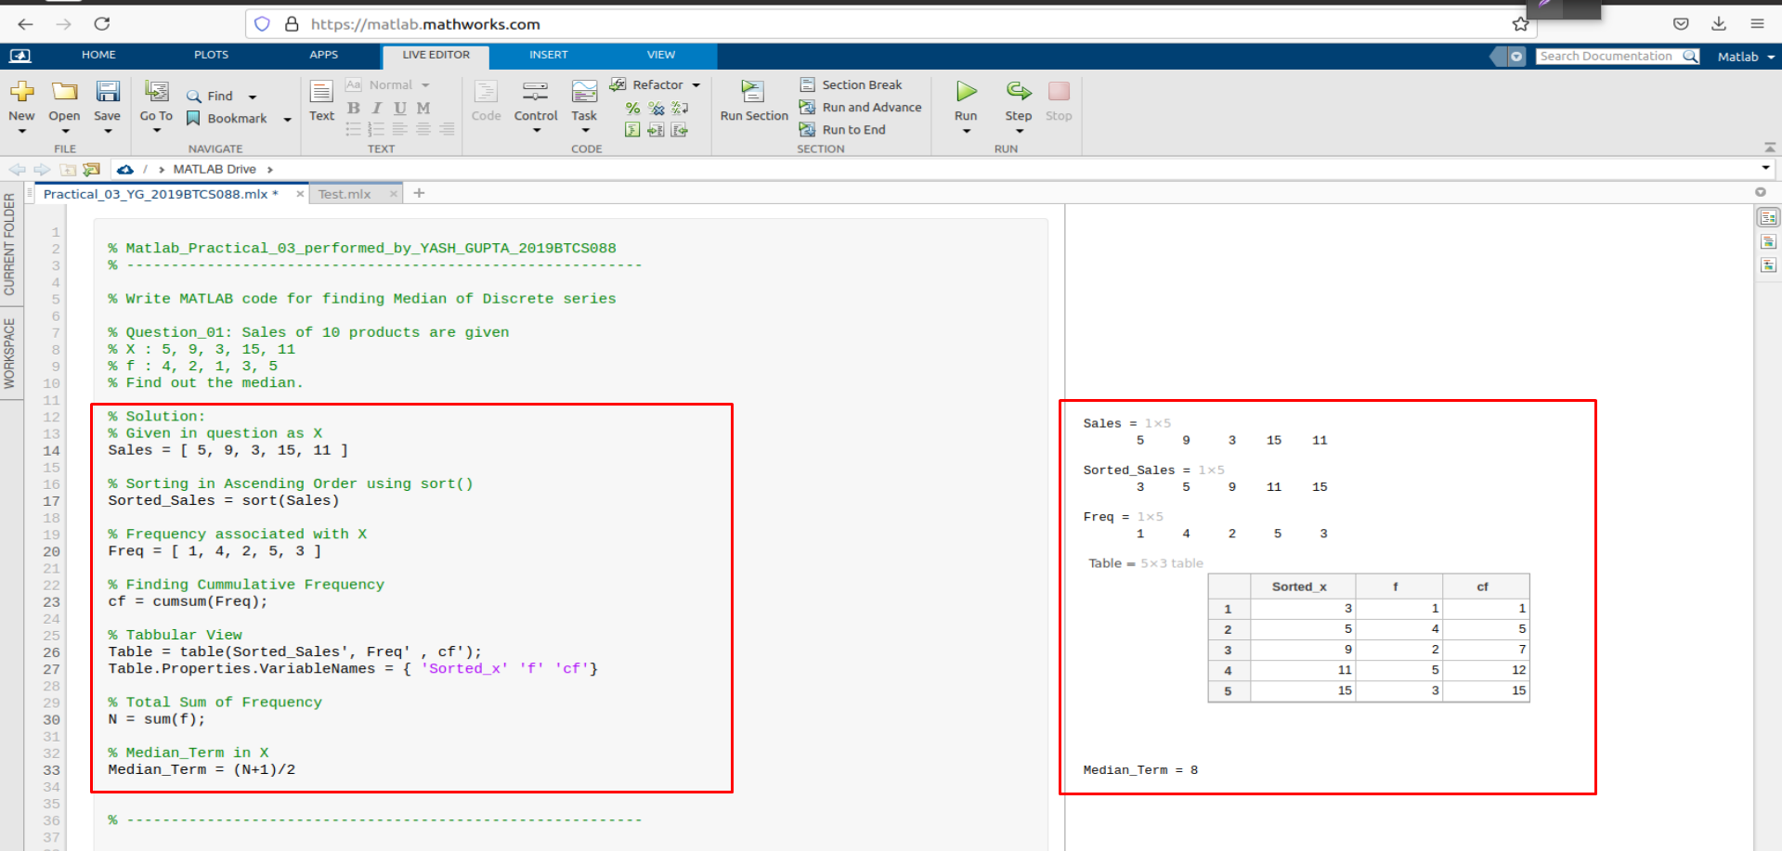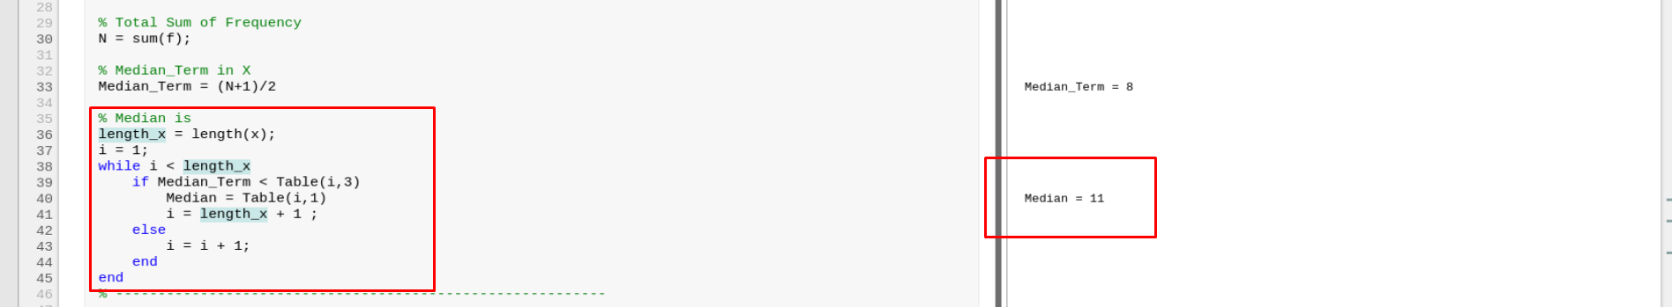
6. **Example 2: Median for Discrete Series.**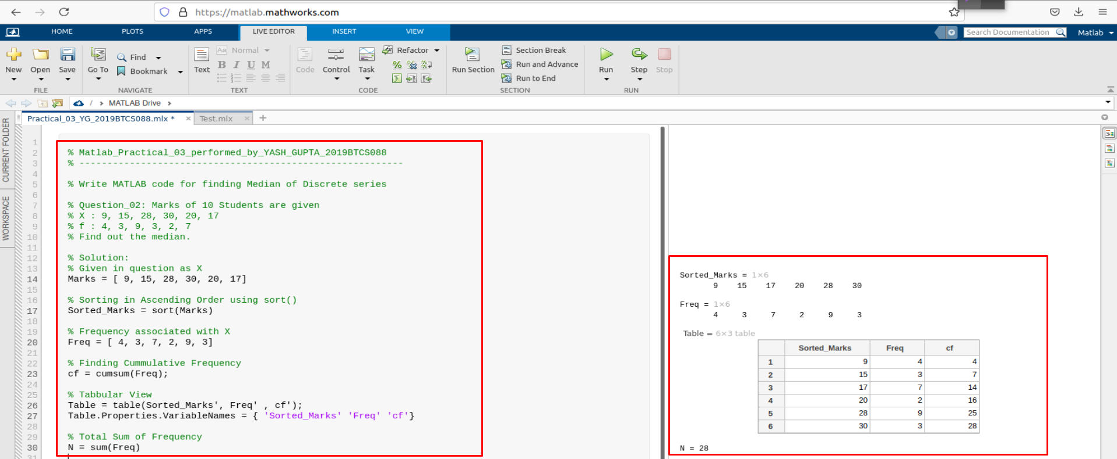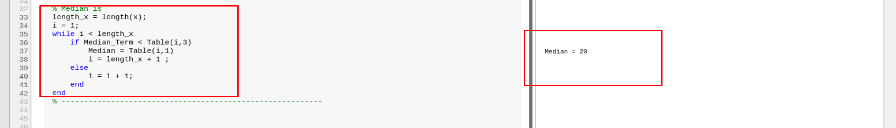
7. **Example 3: Median for Discrete Series.**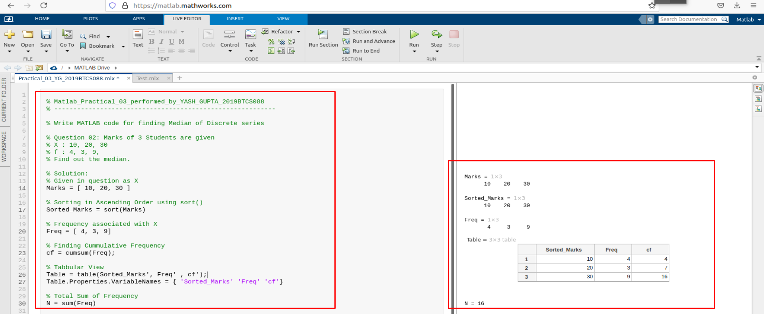

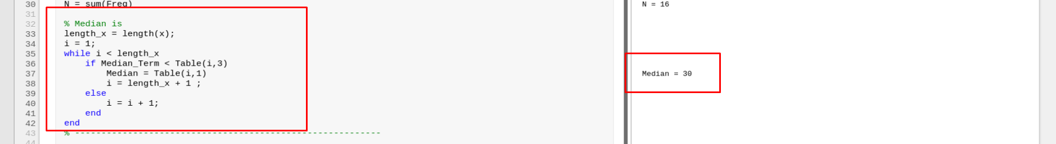

1. **Example 1: Median for Continuous Series.**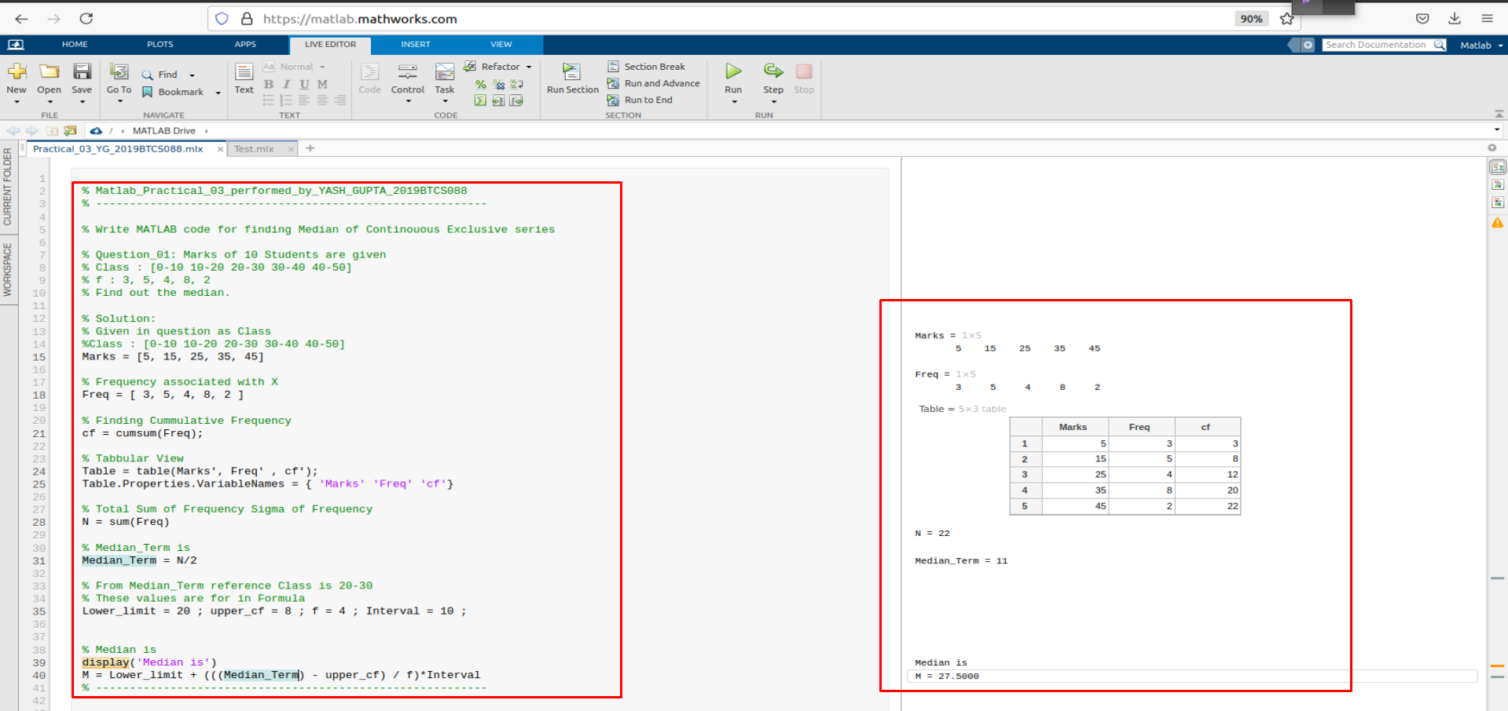
2. **Example 2: Median for Continuous Series.**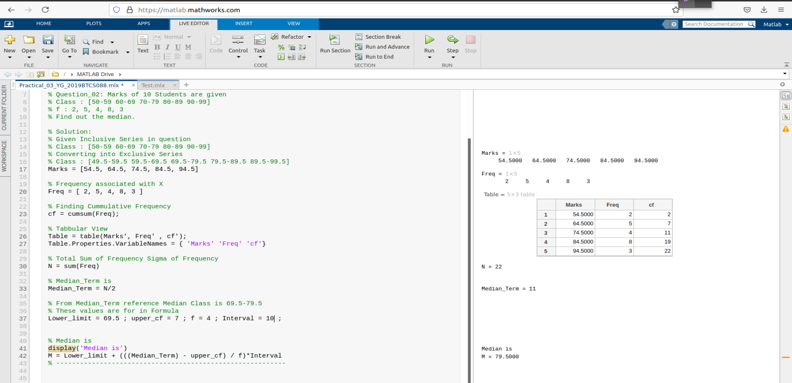
3. **Example 3: Median for Continuous Series.**

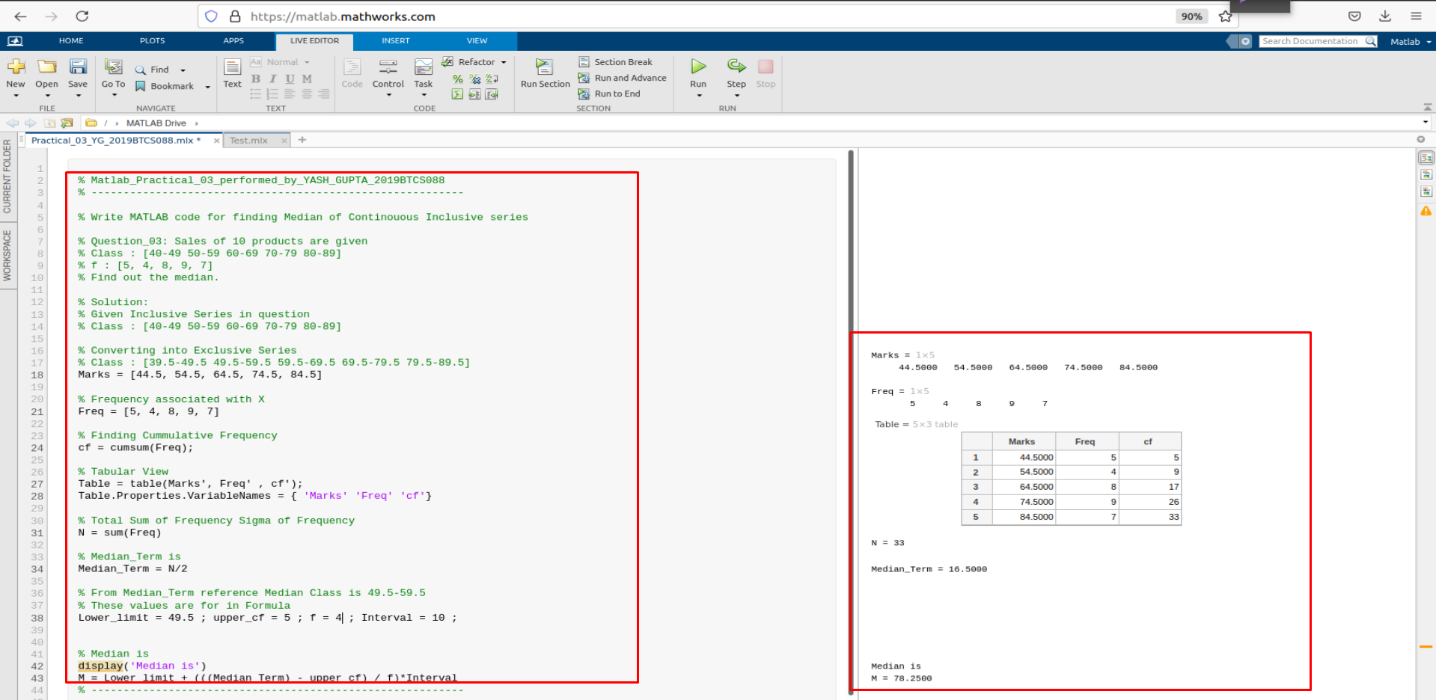

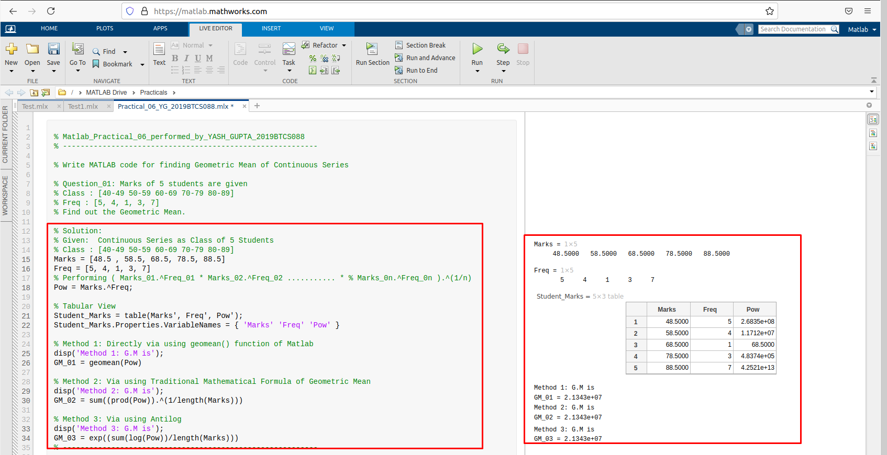

**Assessment Parameters (To be filled by faculty)**

1. **Successful completion of Practical (Y/N)**
2. **Time taken (hours/ minutes)**
3. **List other Parameters & Outcomes:**

|  |  |  |
| --- | --- | --- |
| **S.No.** | **Parameters** | **Outcomes**  **(Achieved / Not Achieved)** |
|  |  |  |
|  |  |  |
|  |  |  |
|  |  |  |
|  |  |  |
|  |  |  |
|  |  |  |
|  |  |  |
|  |  |  |
|  |  |  |

**Remarks:**

Practical No: 02  
(Mode for all 3 types of Series)

Date: 17-June-2021

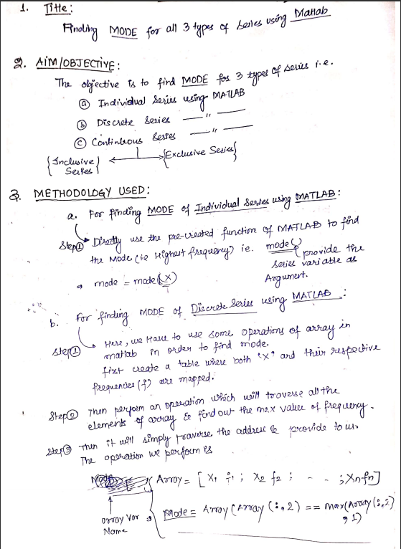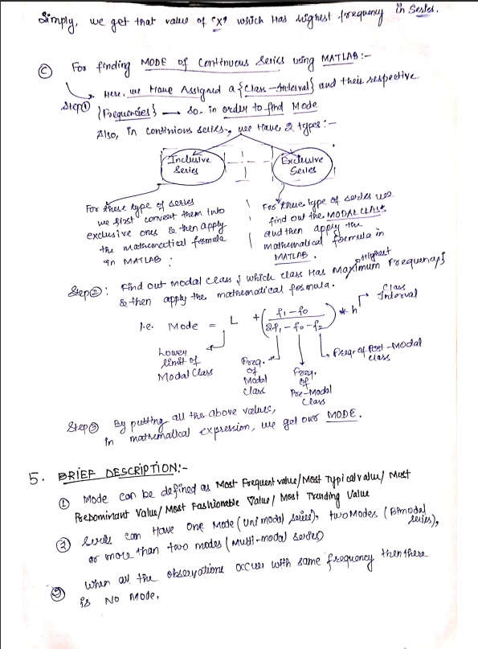

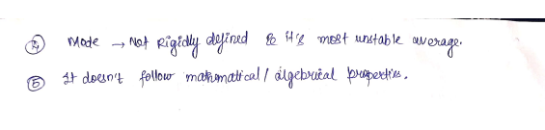

1. **MATLAB CODE:**
2. **Example 1: Mode for Individual Series.**

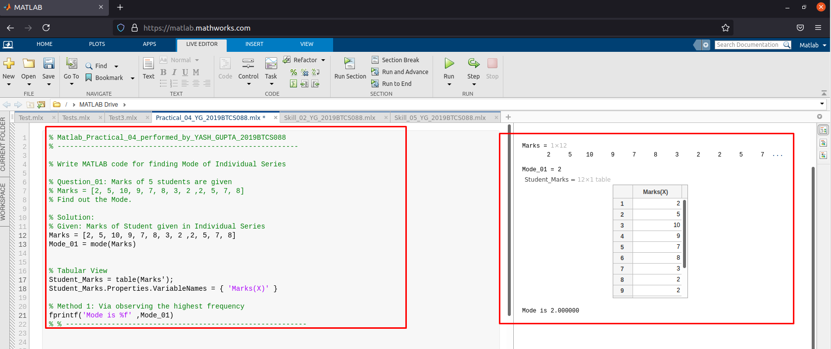

1. **Example 2: Mode for Individual Series.**

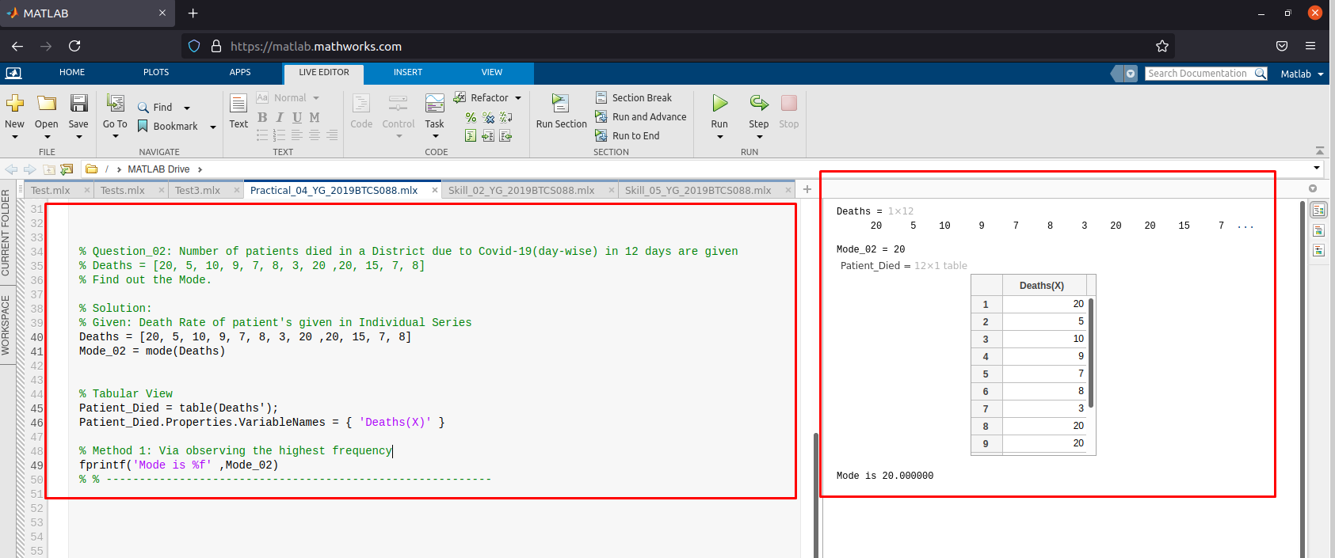

1. **Example 3: Mode for Individual Series.**

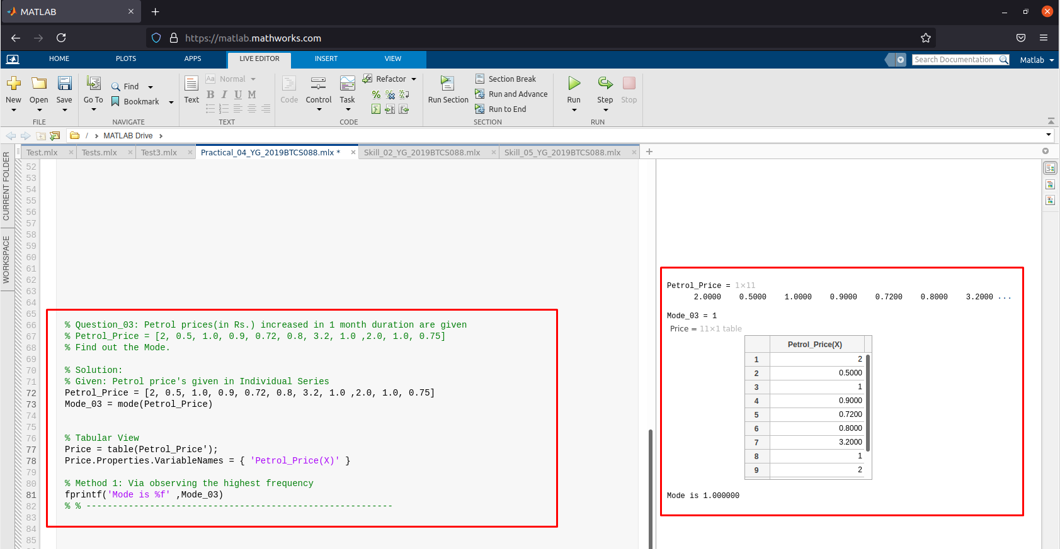

1. **Example 1: Mode for Continuous Series.**

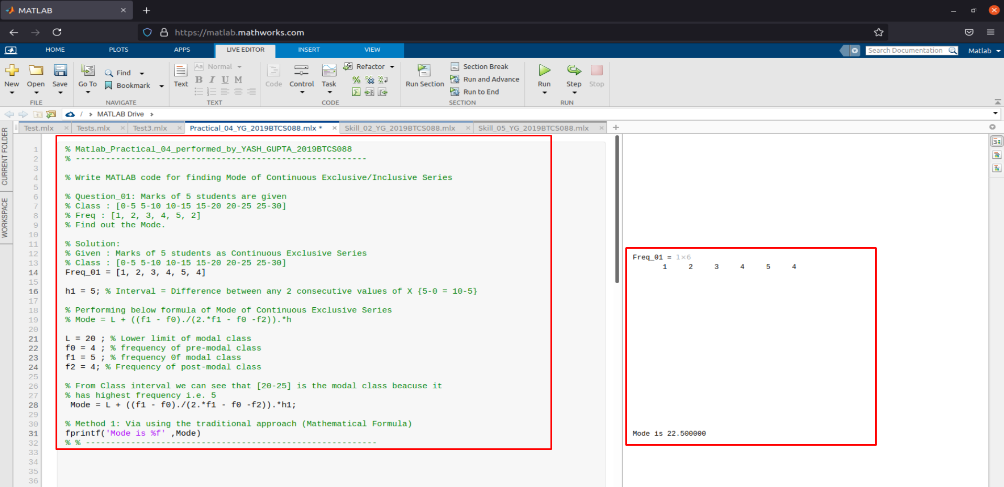

1. **Example 2: Mode for Continuous Series.**

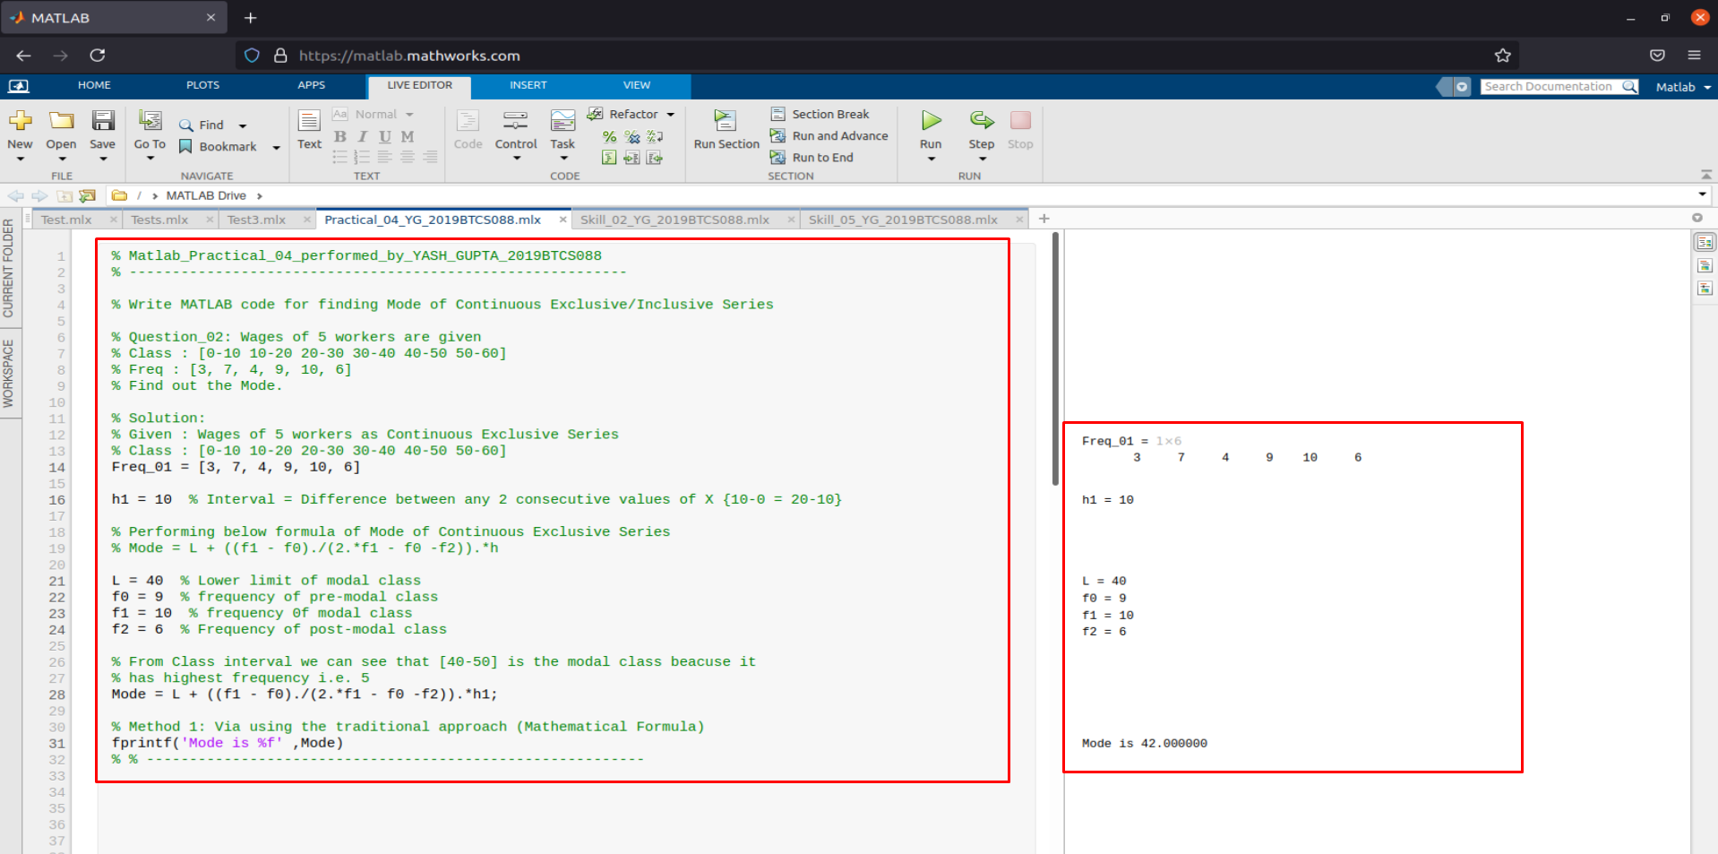

1. **Example 3: Mode for Continuous Series.**

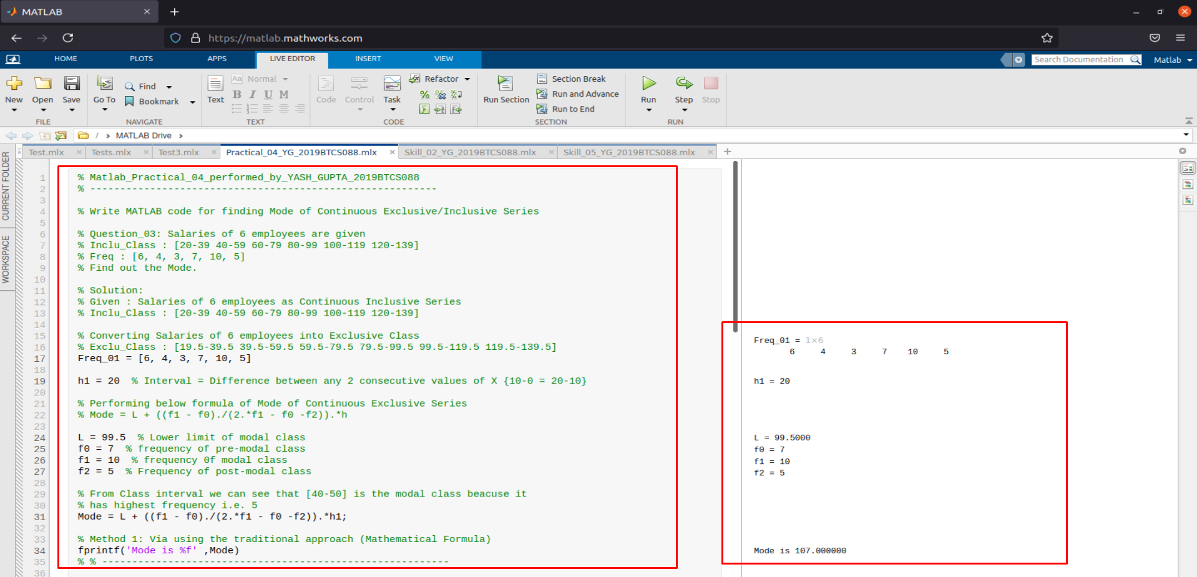

1. **Example 1: Mode for Discrete Series.**

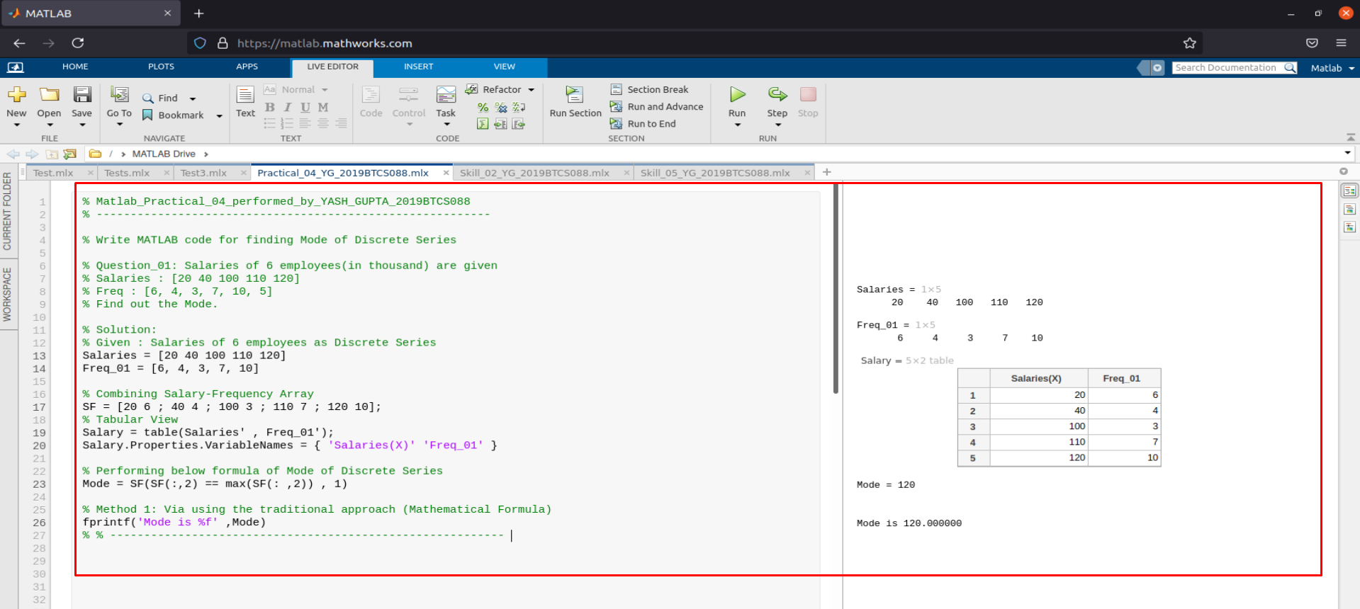

1. **Example 2: Mode for Discrete Series.**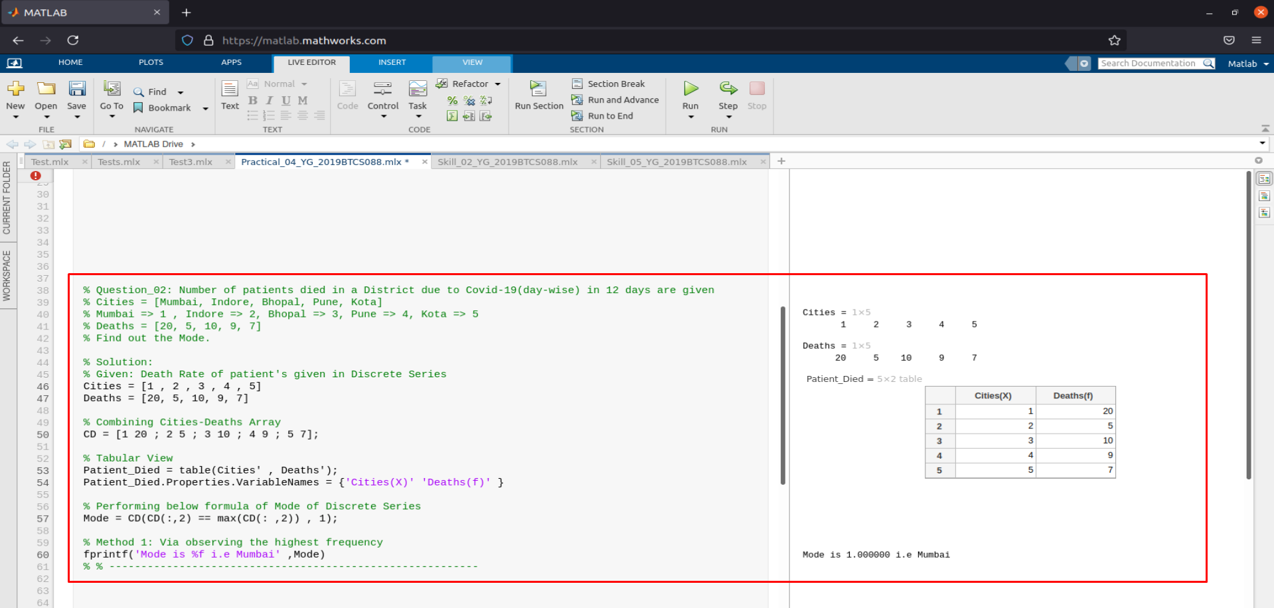
2. **Example 3: Mode for Discrete Series.**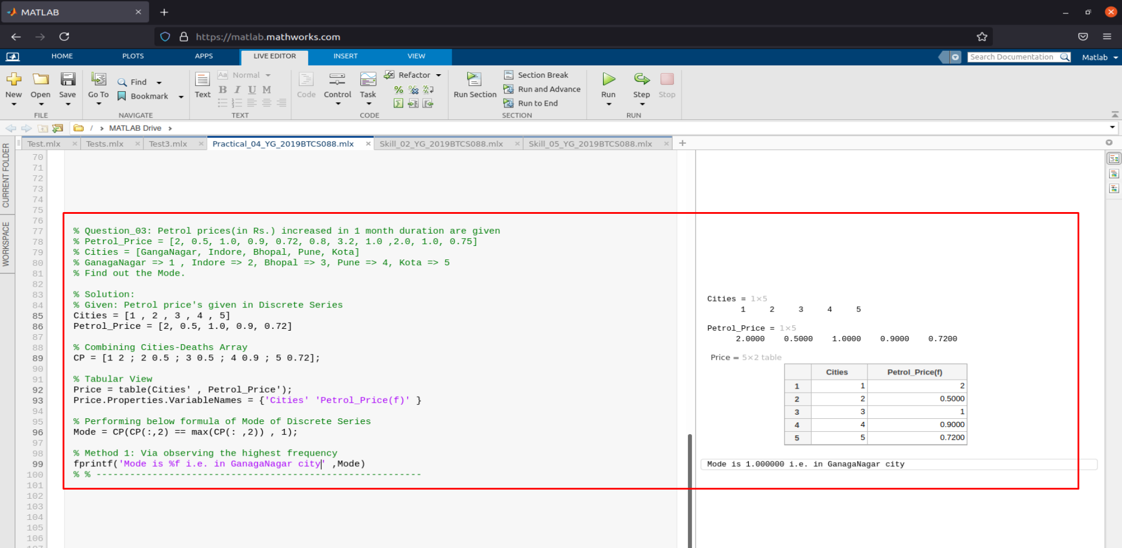

**Assessment Parameters (To be filled by faculty)**

1. **Successful completion of Practical (Y/N)**
2. **Time taken (hours/ minutes)**
3. **List other Parameters & Outcomes:**

|  |  |  |
| --- | --- | --- |
| **S.No.** | **Parameters** | **Outcomes**  **(Achieved / Not Achieved)** |
|  |  |  |
|  |  |  |
|  |  |  |
|  |  |  |
|  |  |  |
|  |  |  |
|  |  |  |
|  |  |  |
|  |  |  |
|  |  |  |

**Remarks:**

**Total marks __________ out of 10. Sign of Faculty**

Practical No: 03  
(Harmonic Mean for all 3 types of Series)

Date: 15-June-2021

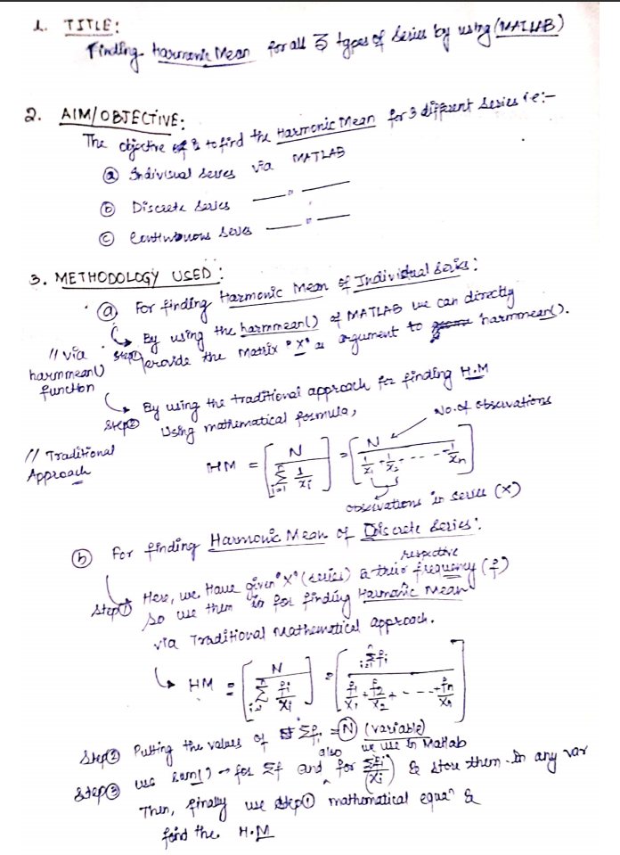

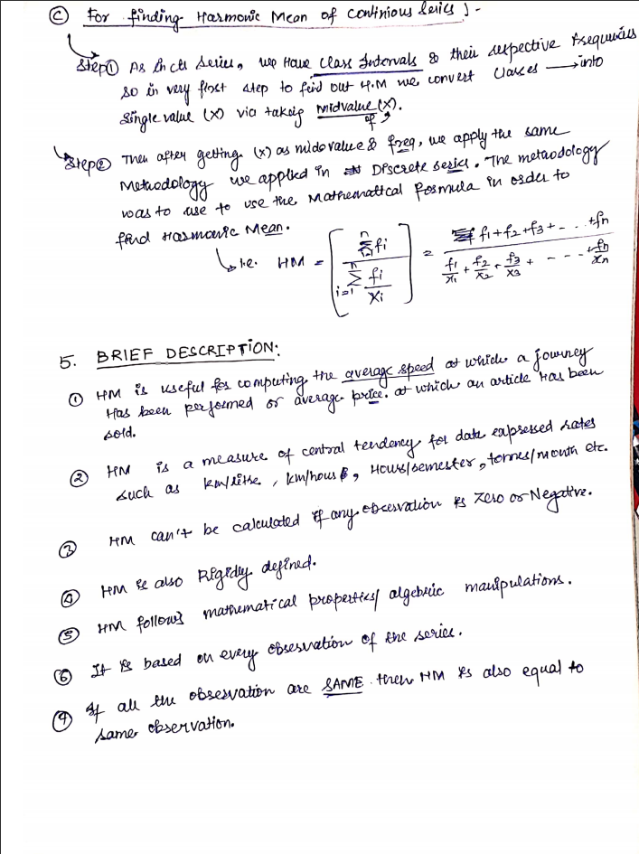

**MATLAB CODE:**

1. **Example 1: Harmonic Mean for Individual Series.**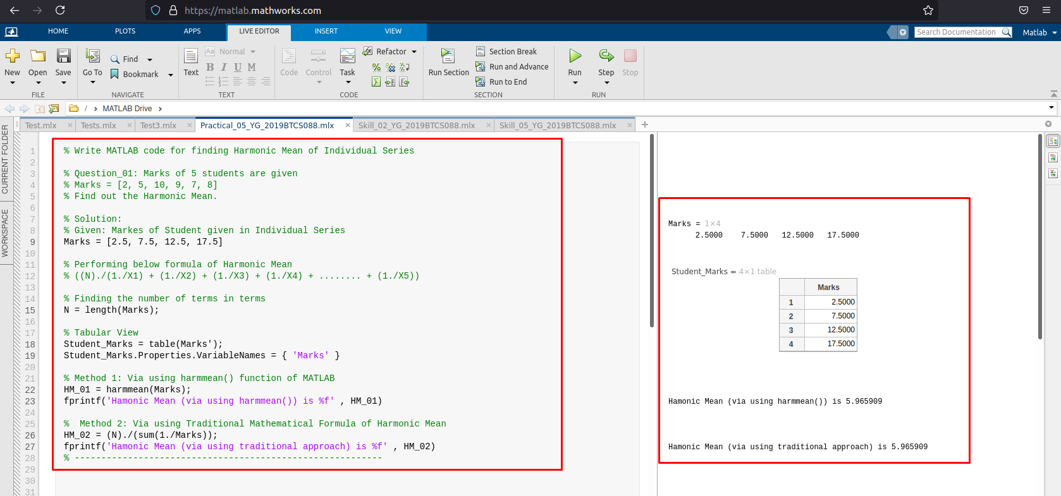
2. **Example 2: Harmonic Mean for Individual Series.**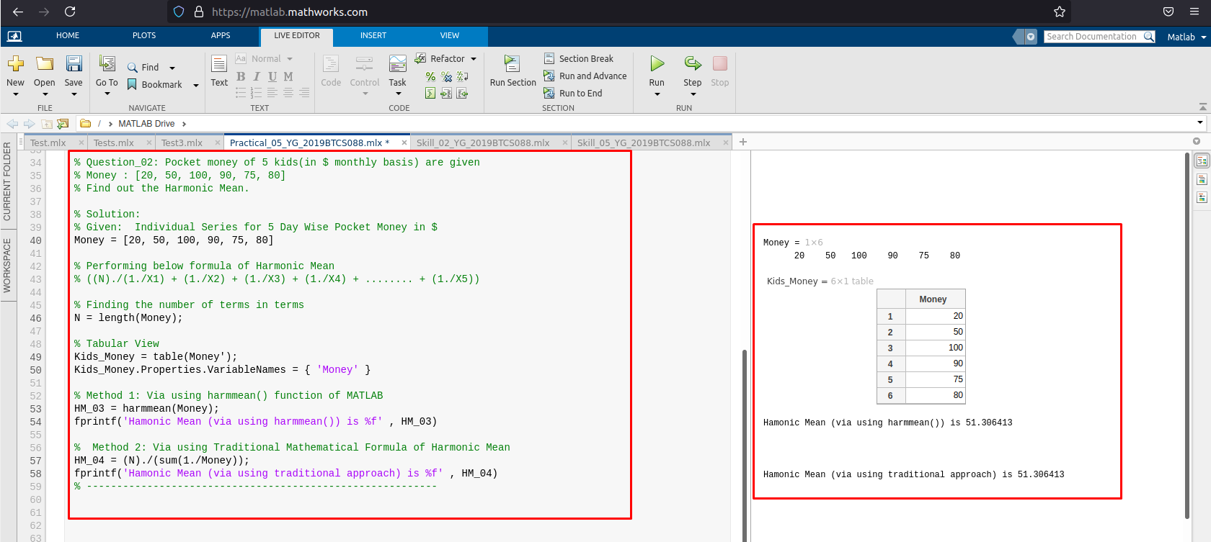
3. **Example 3: Harmonic Mean for Individual Series.**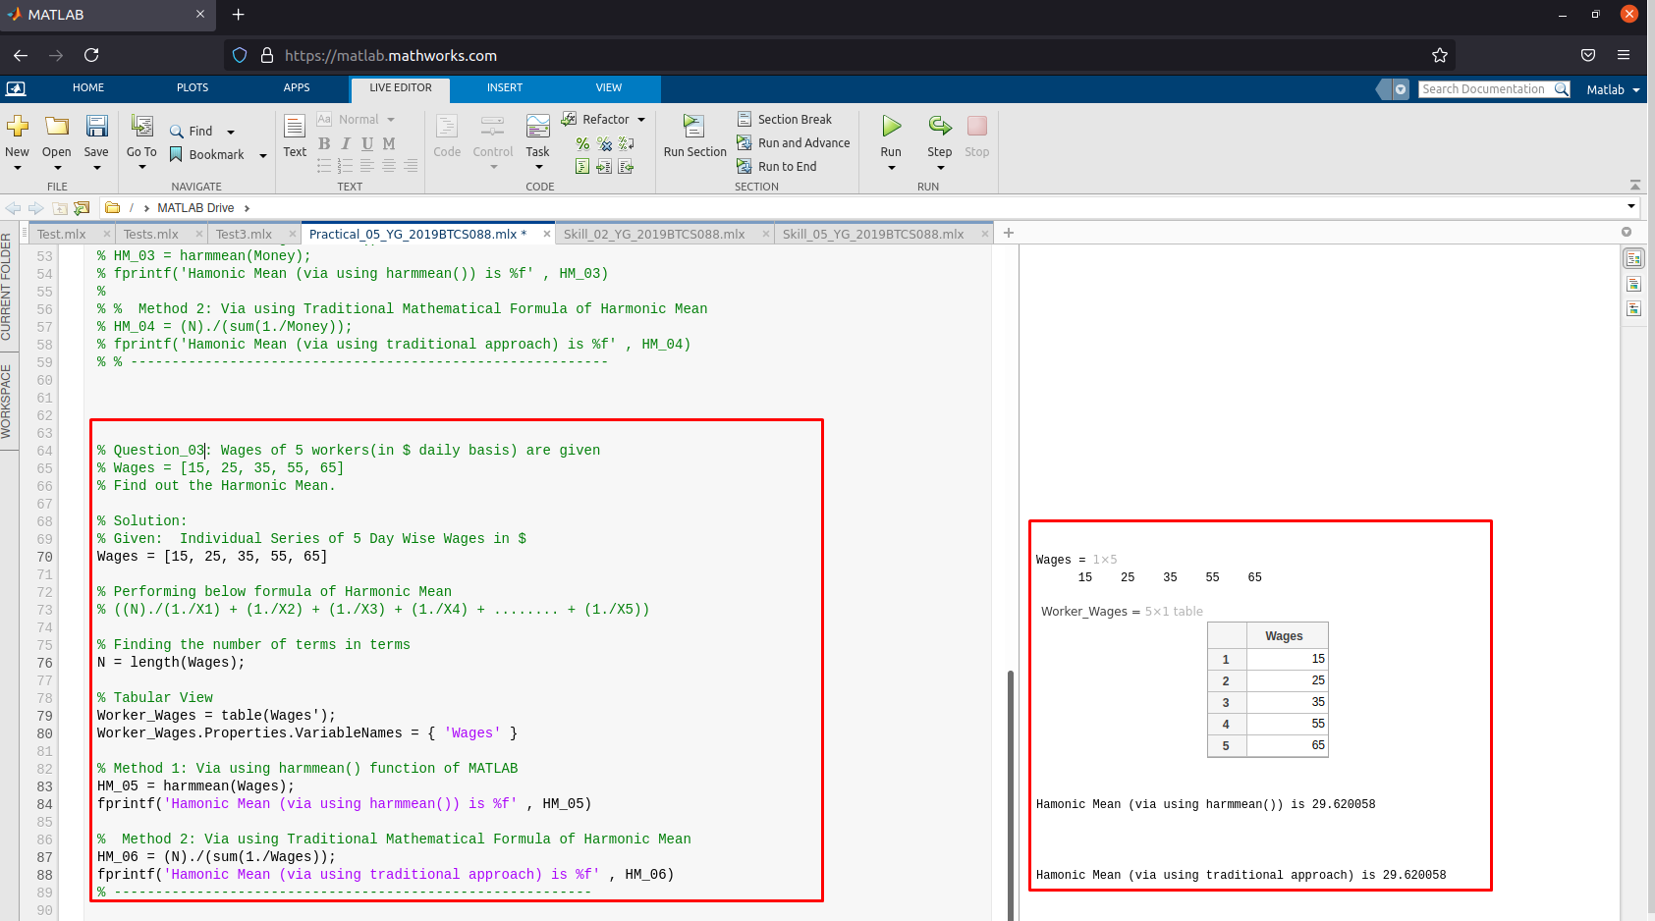
4. **Example 2: Harmonic Mean for Discrete Series.**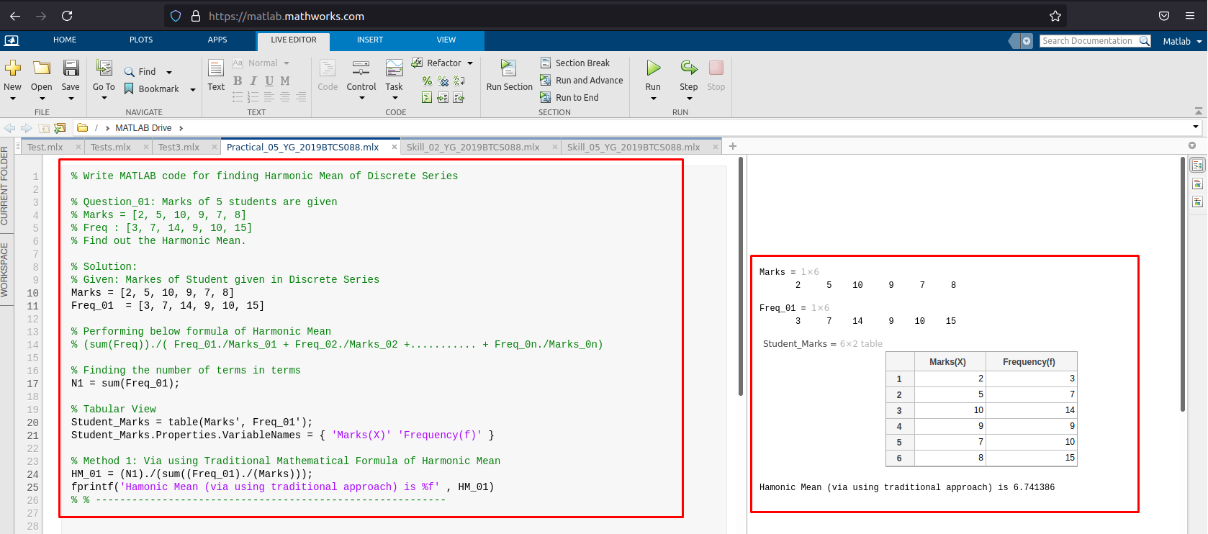
5. **Example 3: Harmonic Mean for Discrete Series.**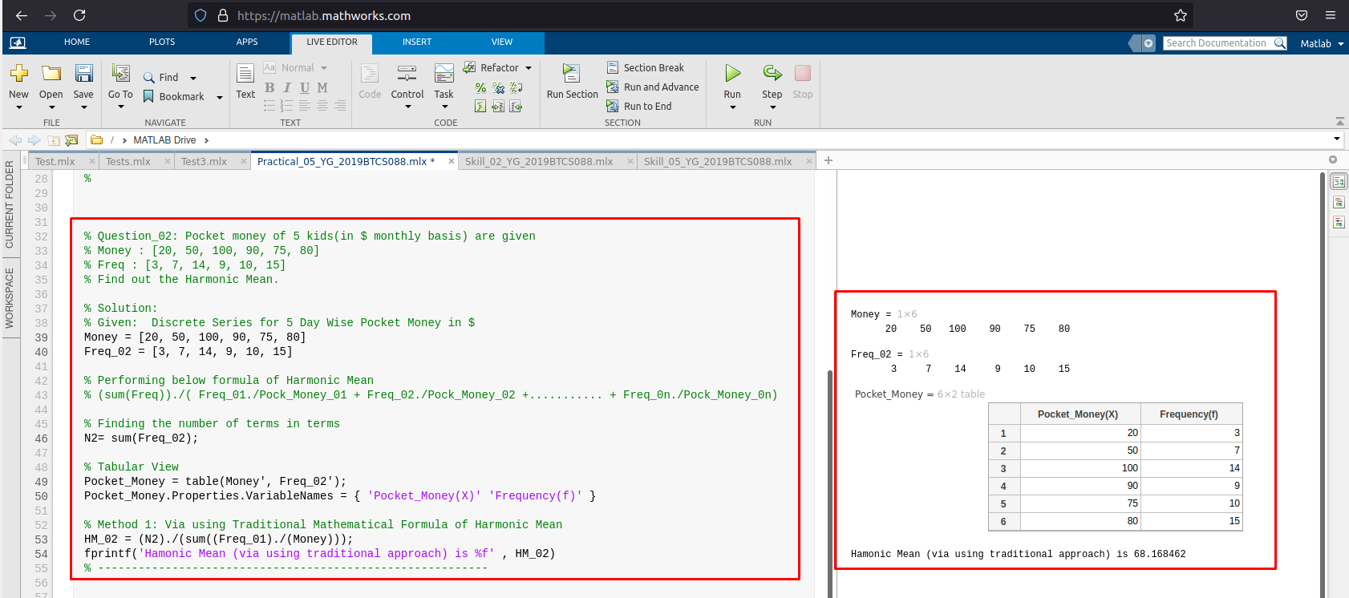
6. **Example 3: Harmonic Mean for Discrete Series.**

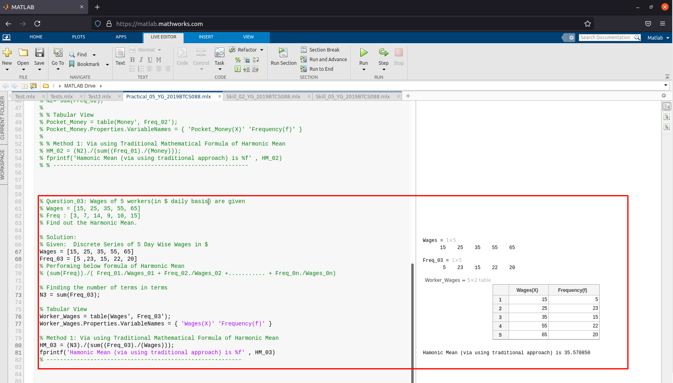

**G. Example 1: Harmonic Mean for Continuous Series.**

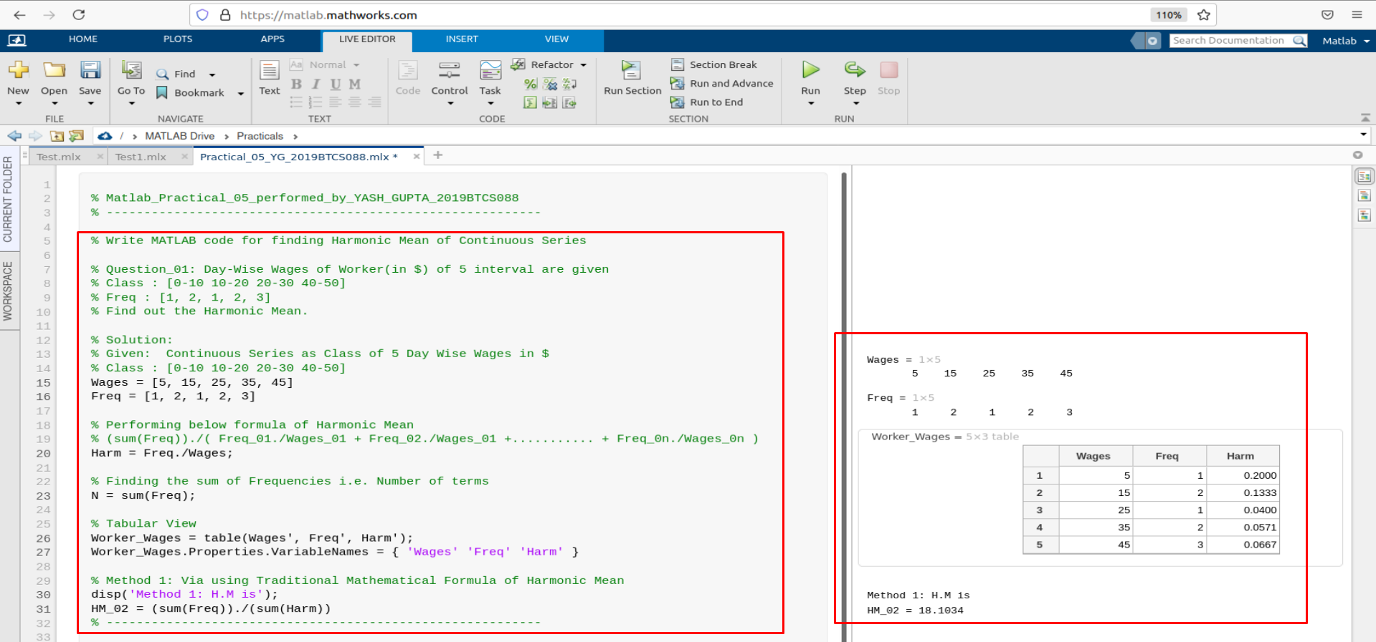

**H. Example 2: Harmonic Mean for Continuous Series.**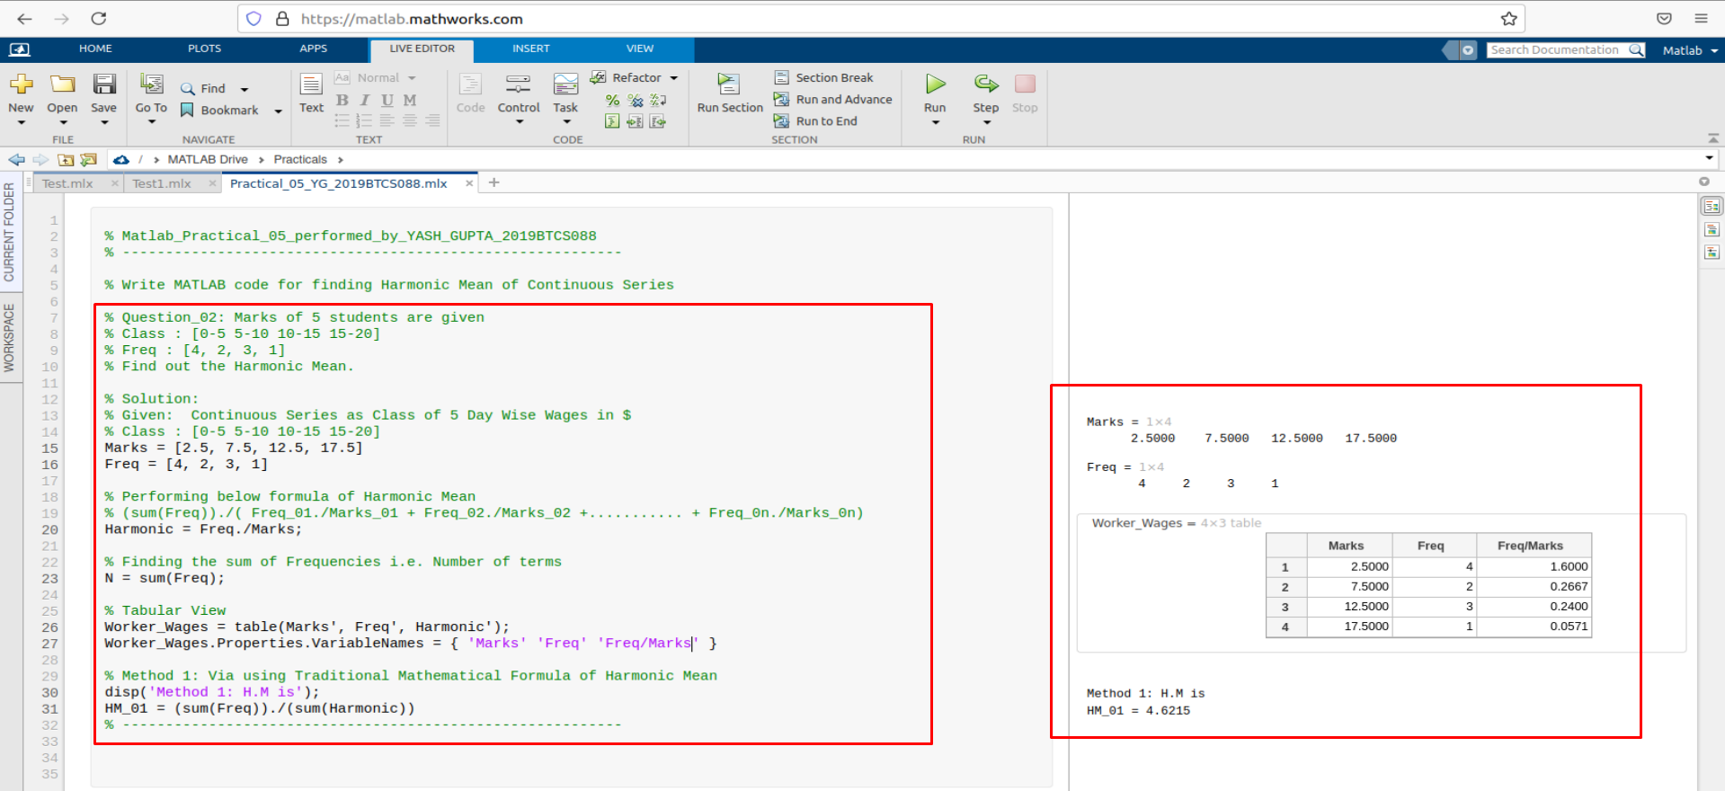

**I. Example 3: Harmonic Mean for Continuous Series.**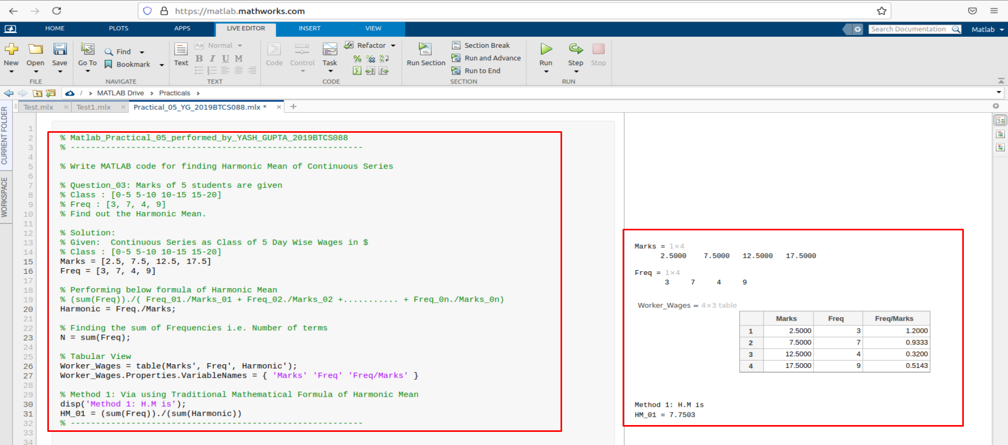

**Assessment Parameters (To be filled by faculty)**

1. **Successful completion of Practical (Y/N)**
2. **Time taken (hours/ minutes)**
3. **List other Parameters & Outcomes:**

|  |  |  |
| --- | --- | --- |
| **S.No.** | **Parameters** | **Outcomes**  **(Achieved / Not Achieved)** |
|  |  |  |
|  |  |  |
|  |  |  |
|  |  |  |
|  |  |  |
|  |  |  |
|  |  |  |
|  |  |  |
|  |  |  |
|  |  |  |

**Remarks:**

**Total marks __________ out of 10. Sign of Faculty**

Practical No: 04

(Geometric Mean for all 3 Types of Series)

Date: 15-June-2021

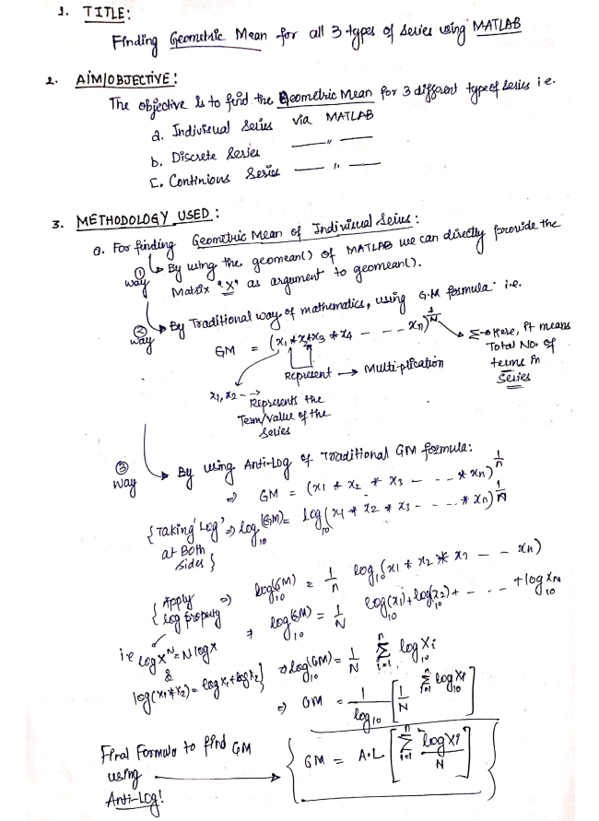

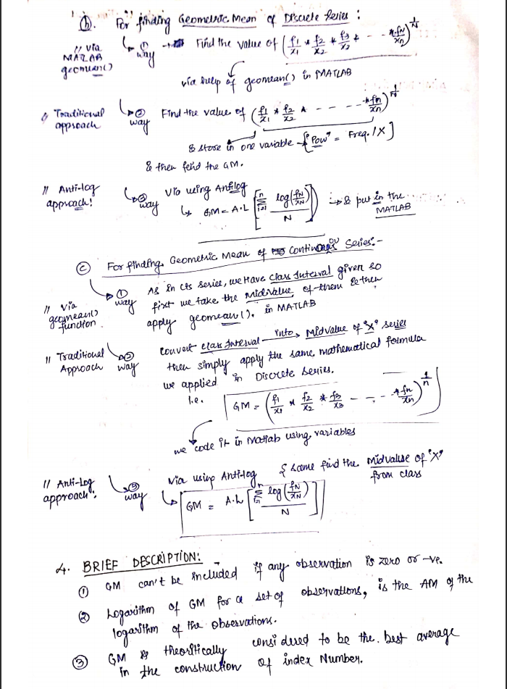

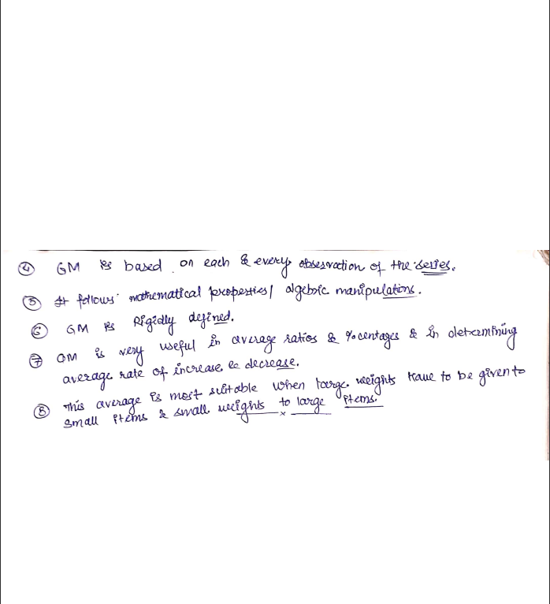

1. **MATLAB CODE:**

**A. Example 1: Geometric Mean for Individual Series.**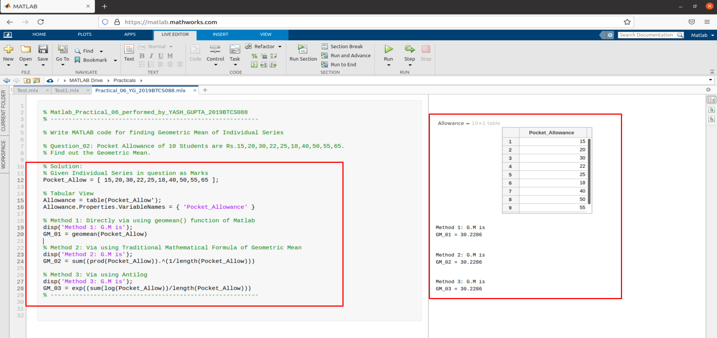

**B. Example 2: Geometric Mean for Individual Series.**

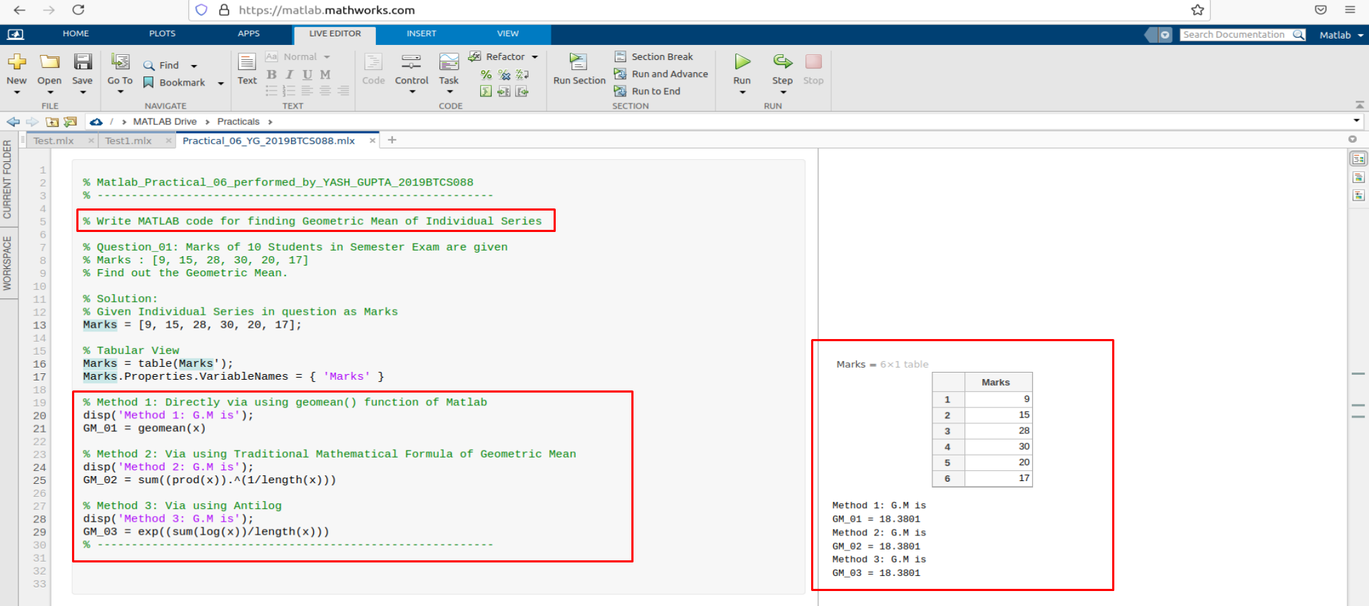

**C. Example 3: Geometric Mean for Individual Series.**

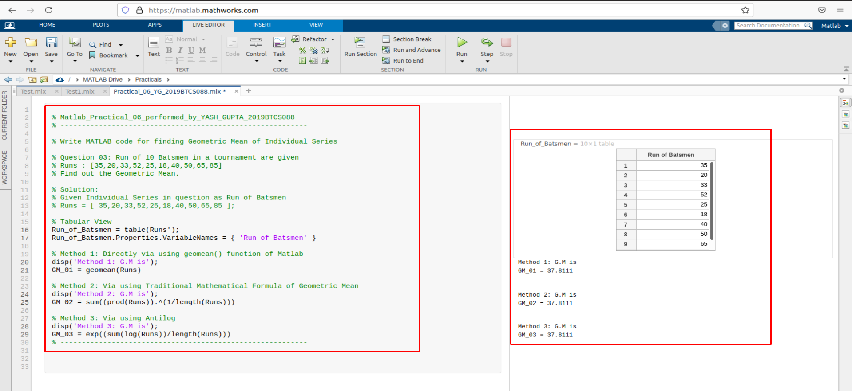

**D. Example 1: Geometric Mean for Discrete Series.**

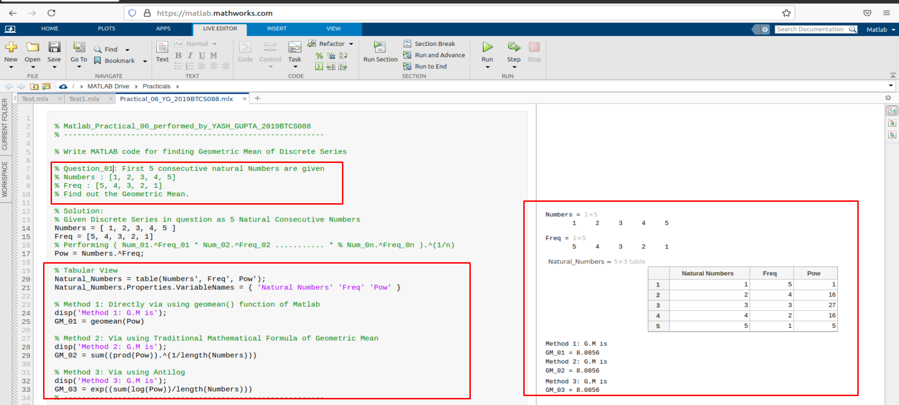

**E. Example 2: Geometric Mean for Discrete Series.**

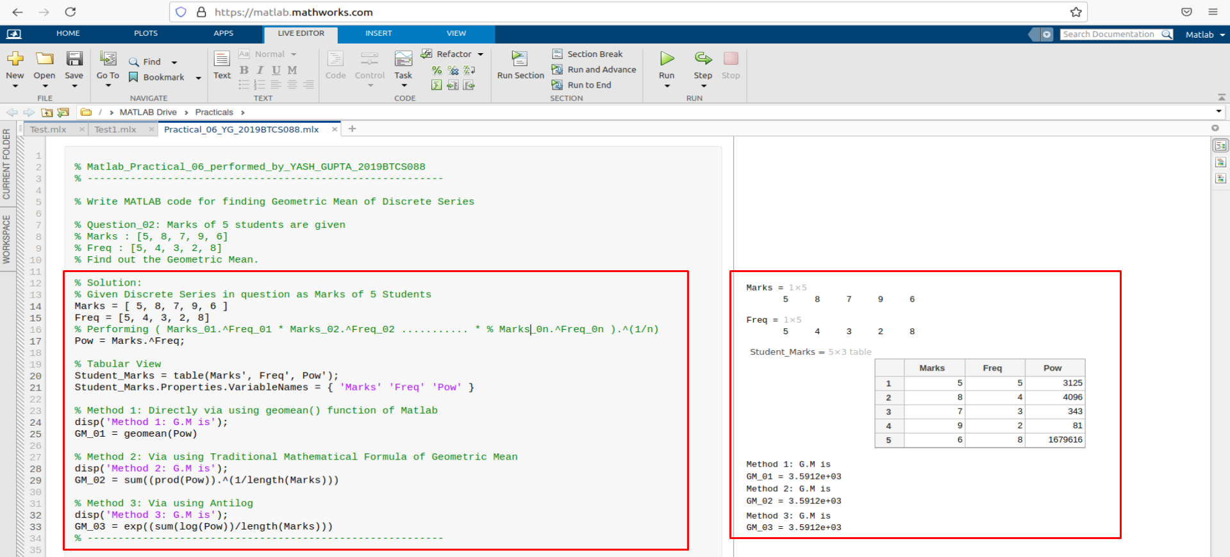

**F. Example 3: Geometric Mean for Discrete Series.**

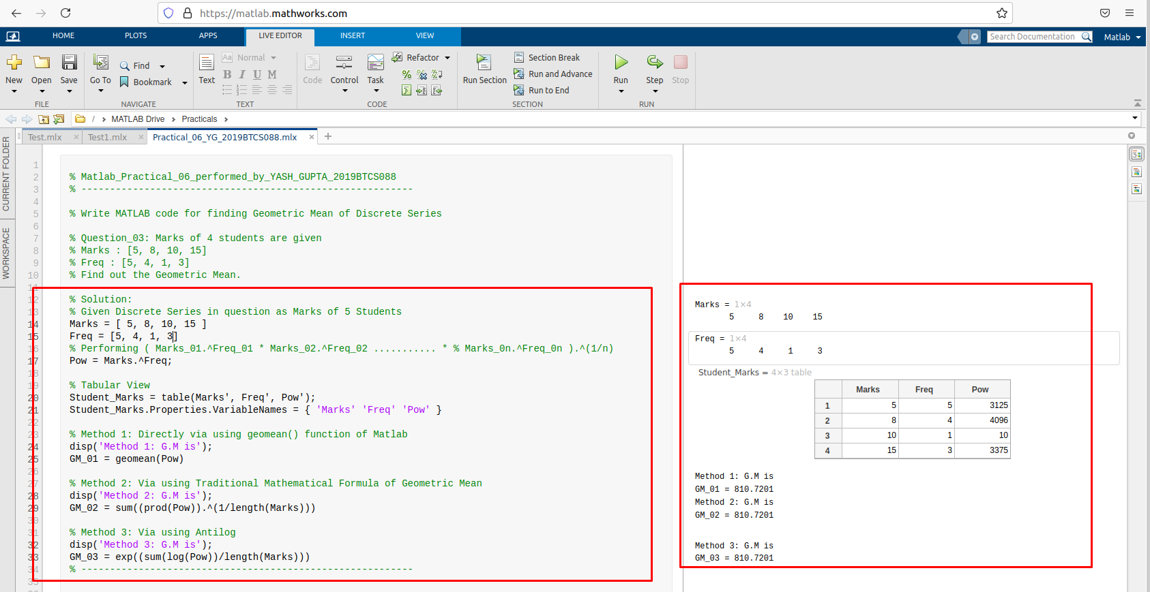 **G. Example 1: Geometric Mean for Continuous Series.**

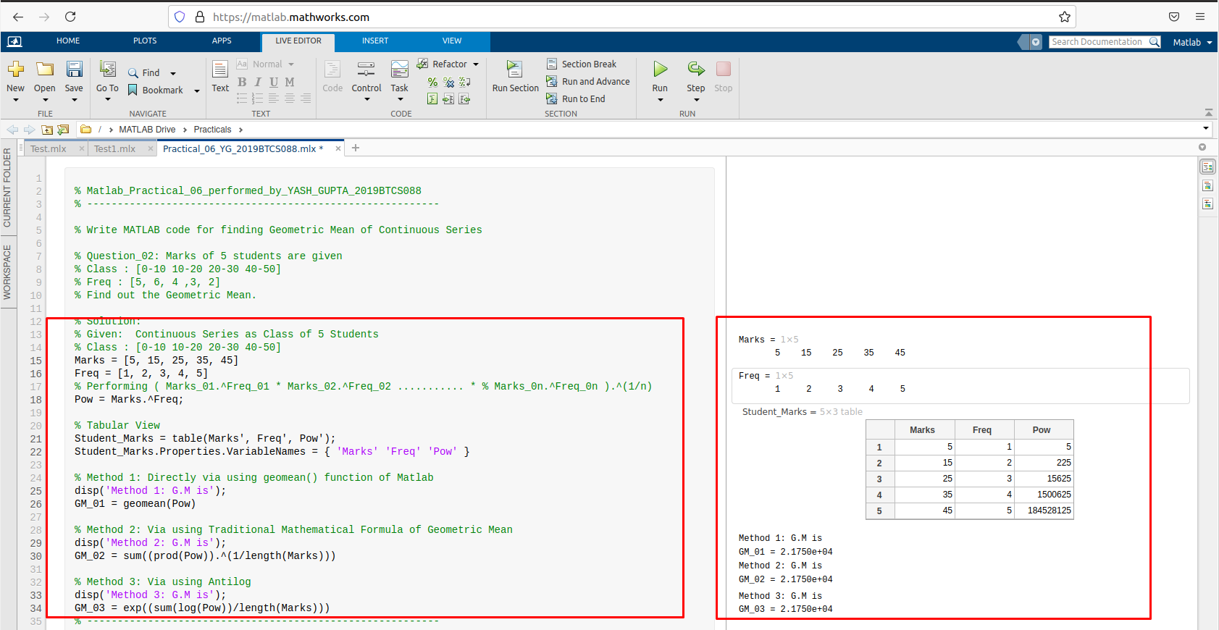

**H. Example 2: Geometric Mean for Continuous Series.**

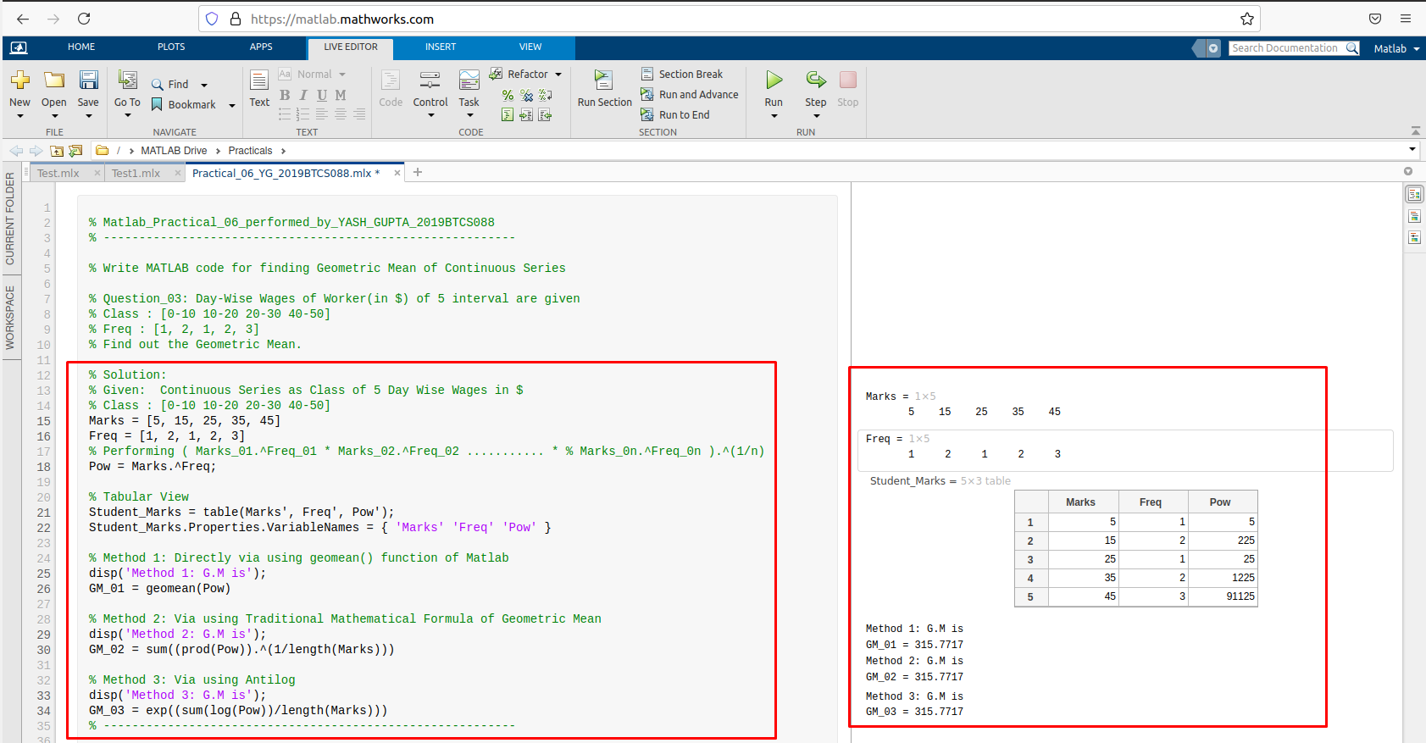

**Assessment Parameters (To be filled by faculty)**

1. **Successful completion of Practical (Y/N)**
2. **Time taken (hours/ minutes)**
3. **List other Parameters & Outcomes:**

|  |  |  |
| --- | --- | --- |
| **S.No.** | **Parameters** | **Outcomes**  **(Achieved / Not Achieved)** |
|  |  |  |
|  |  |  |
|  |  |  |
|  |  |  |
|  |  |  |
|  |  |  |
|  |  |  |
|  |  |  |
|  |  |  |
|  |  |  |

**Remarks:**

**Total marks __________ out of 10. Sign of Faculty**

Practical No: 05

(Arithmetic Mean for all 3 Types of Series)

Date: 15-June-2021

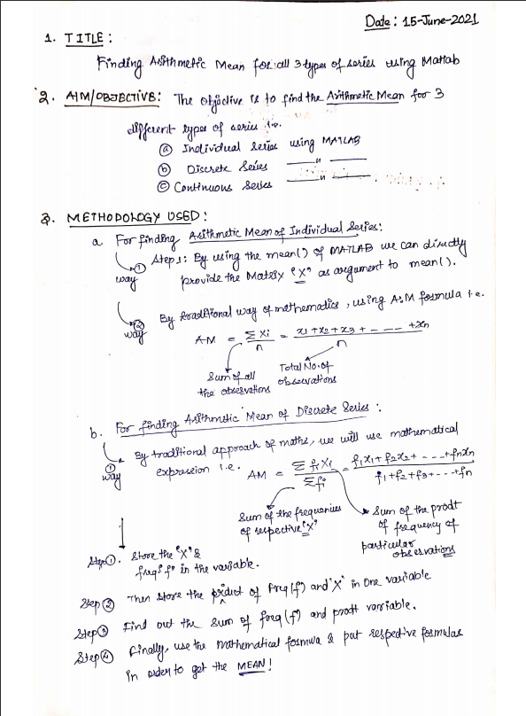

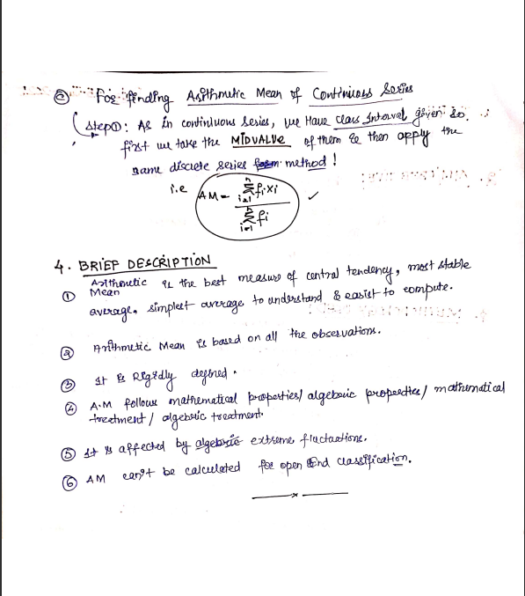

1. **MATLAB CODE:**

**A. Example 1: Arithmetic Mean for Individual Series.**

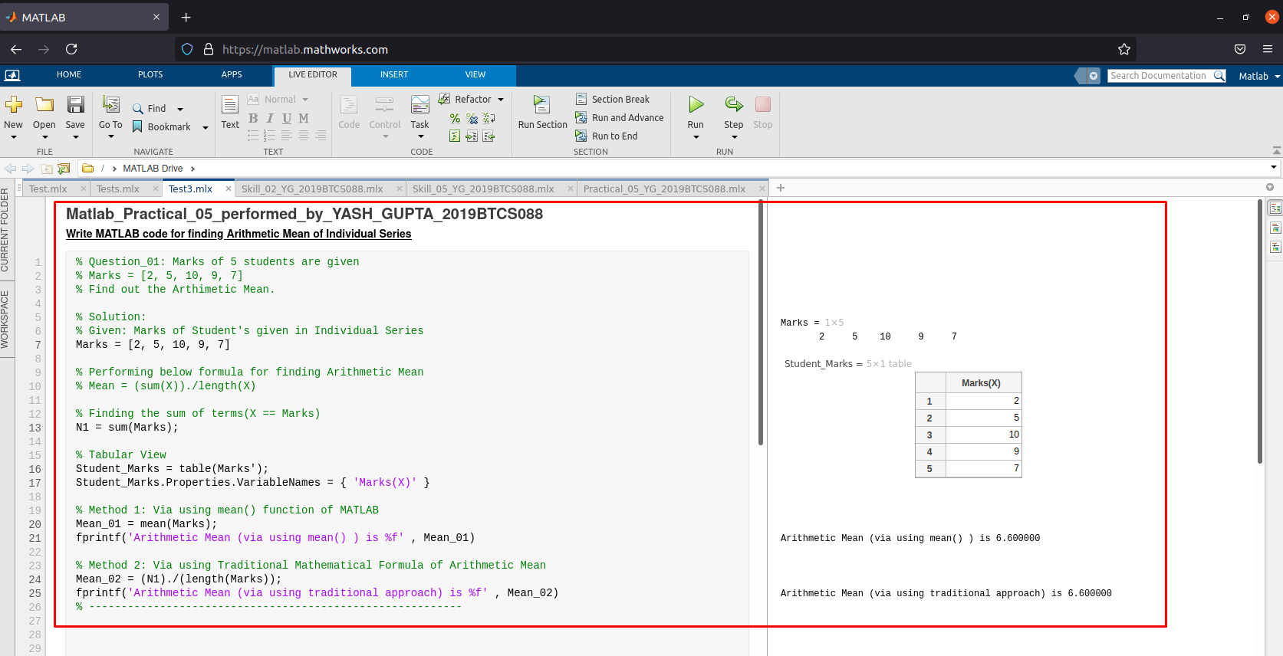

**B. Example 2: Arithmetic Mean for Individual Series.**

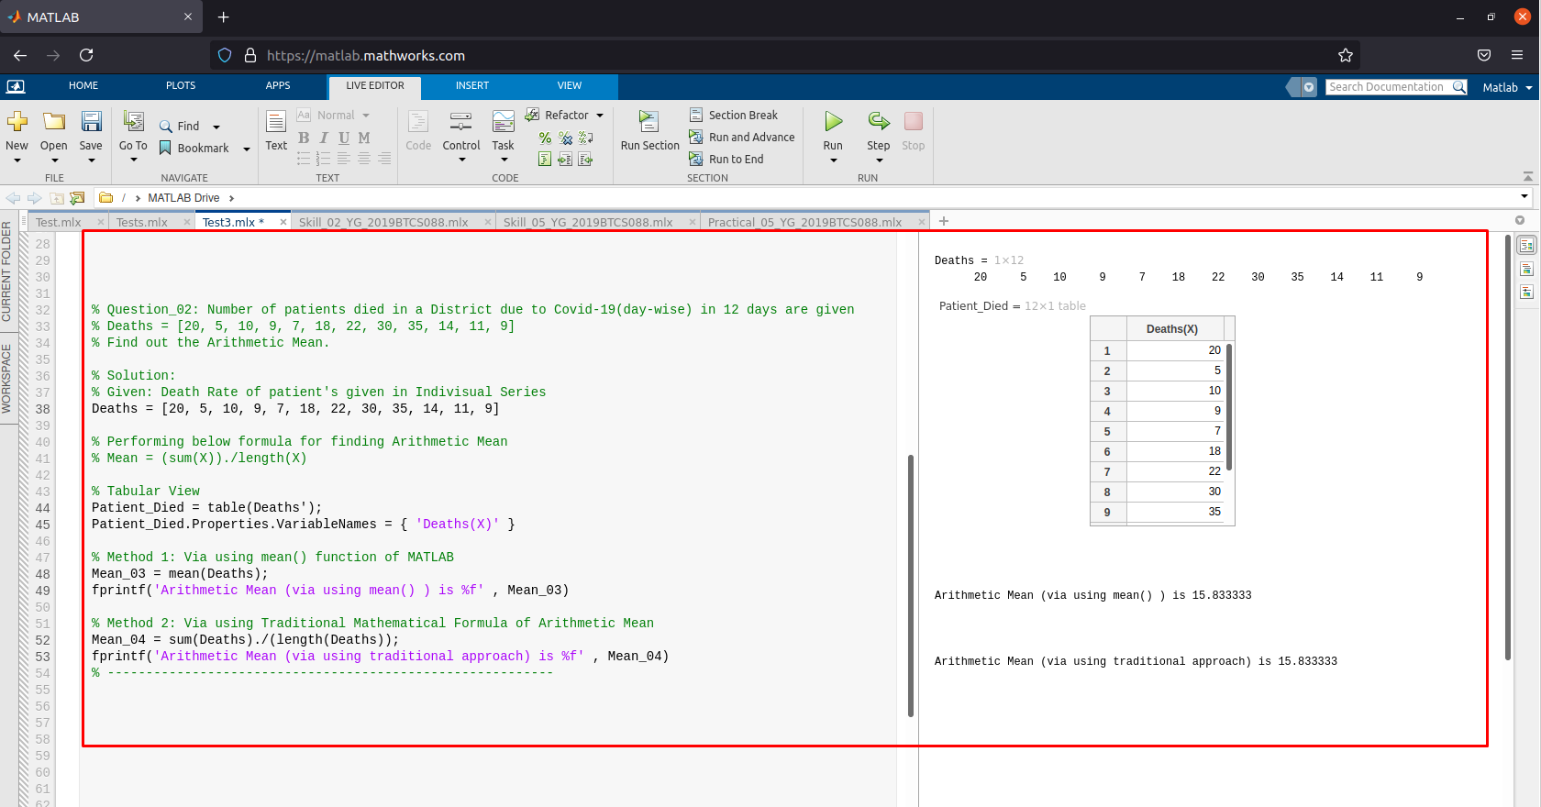

**C. Example 3: Arithmetic Mean for Individual Series.**

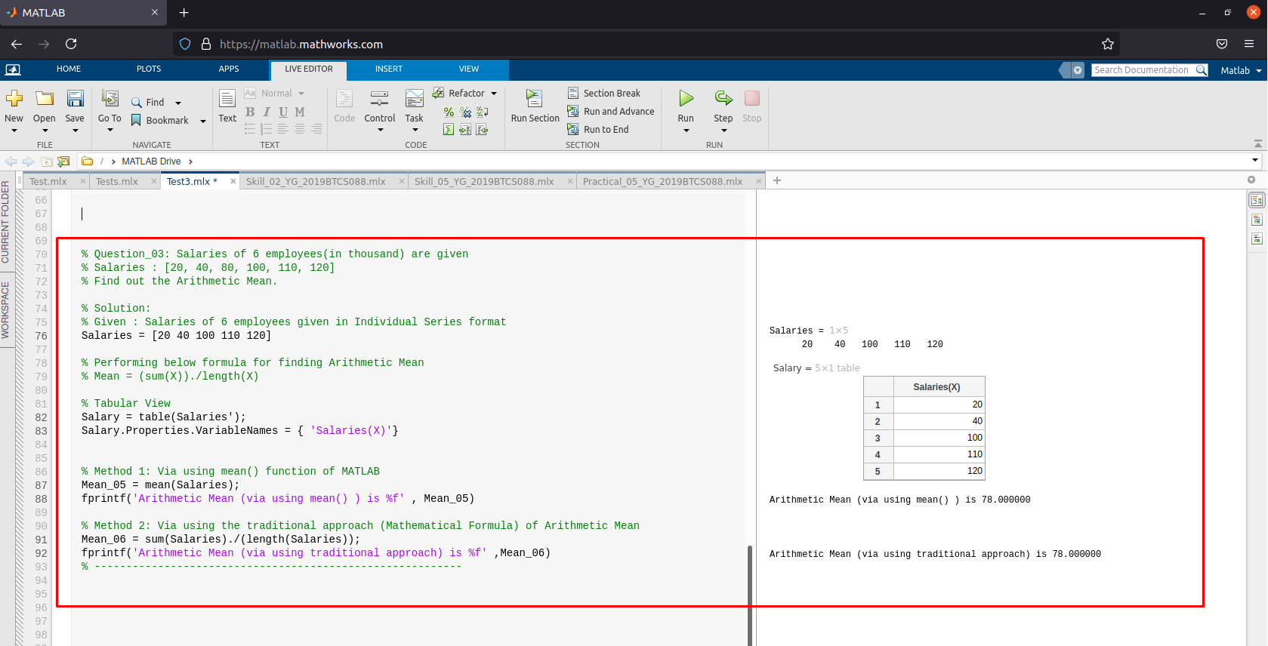 **D. Example 1: Arithmetic Mean for Discrete Series.**

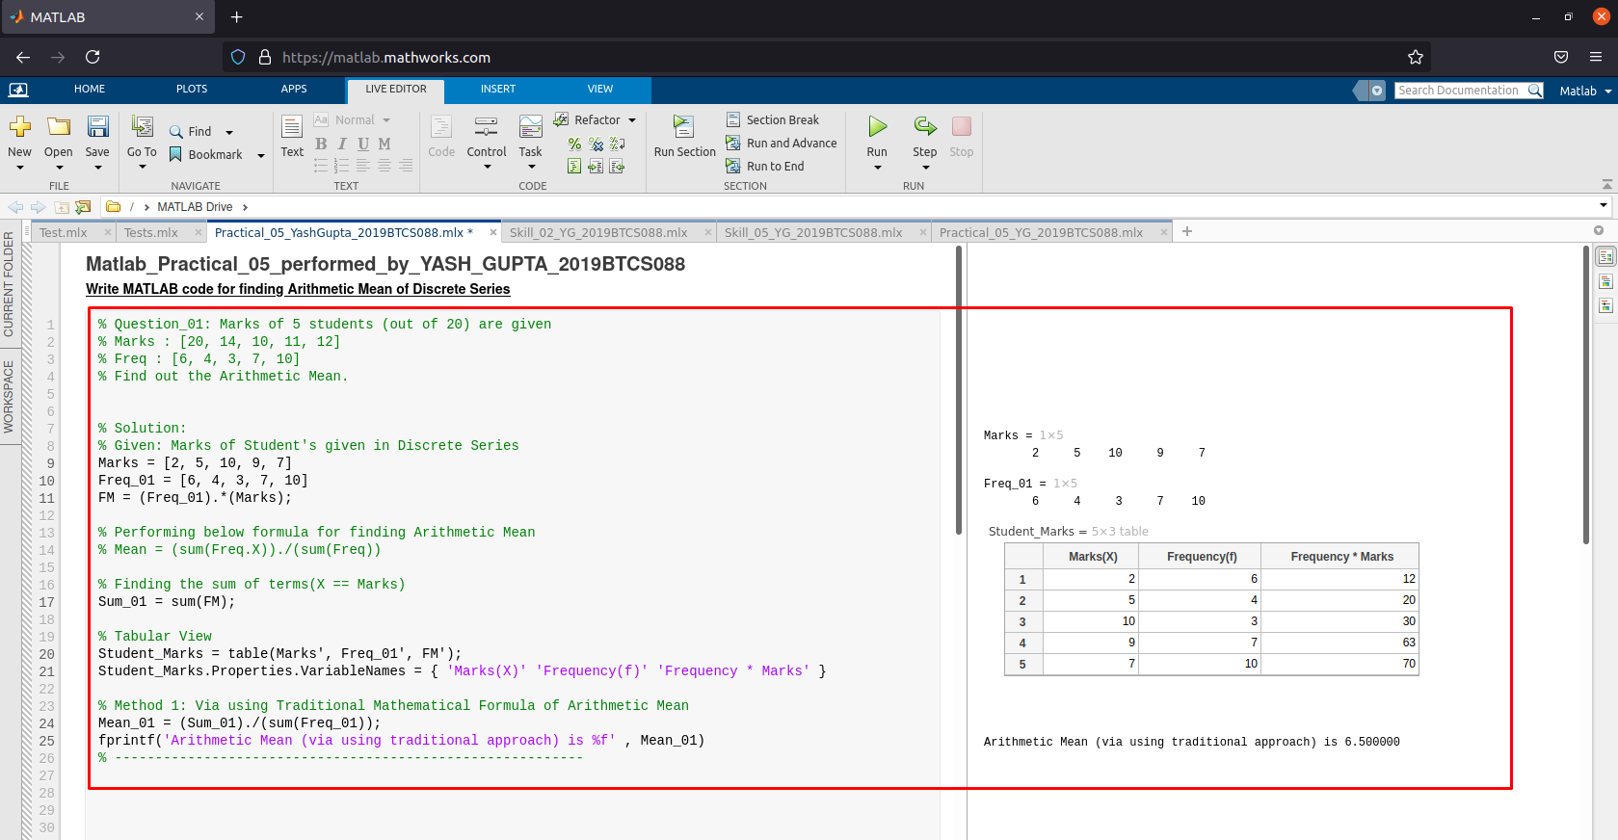

**E. Example 2: Arithmetic Mean for Discrete Series.**

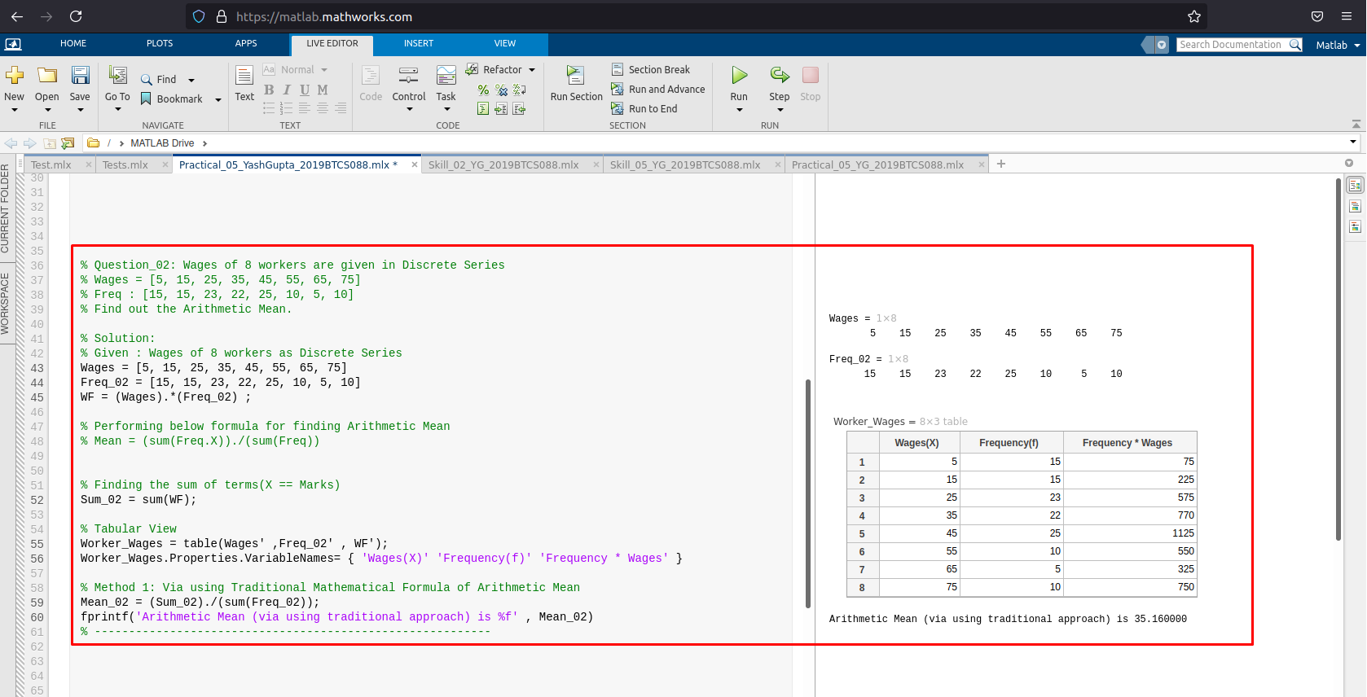 **F. Example 3: Arithmetic Mean for Discrete Series.**

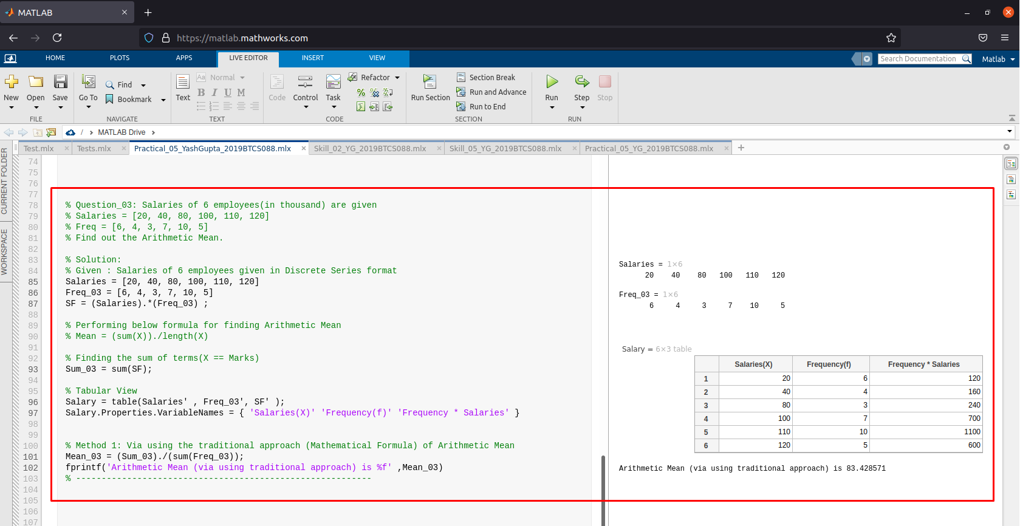

**G. Example 1: Arithmetic Mean for Continuous Series.**

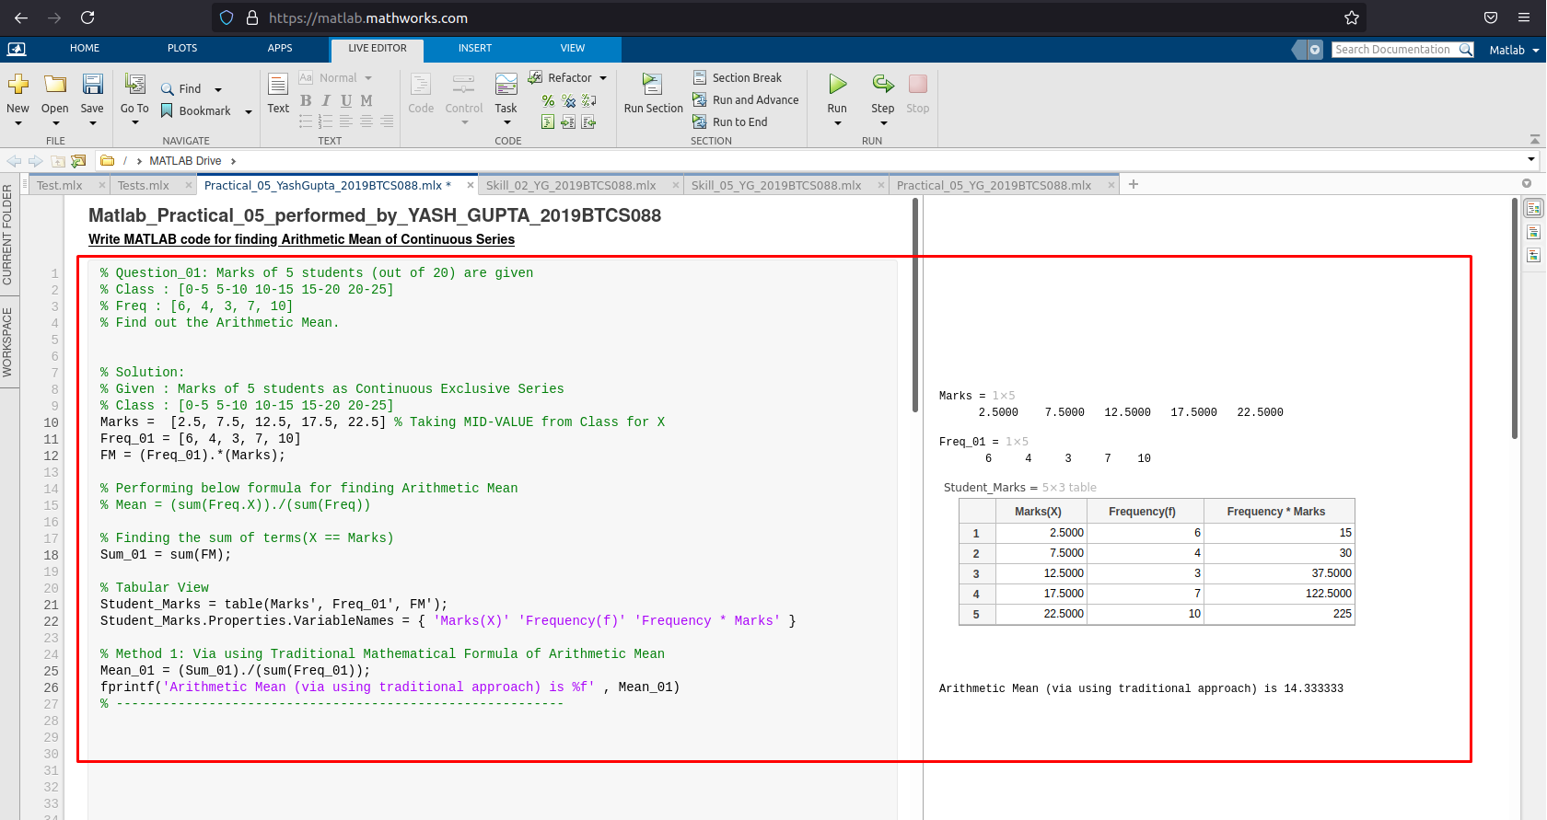

**H. Example 2: Arithmetic Mean for Continuous Series.**

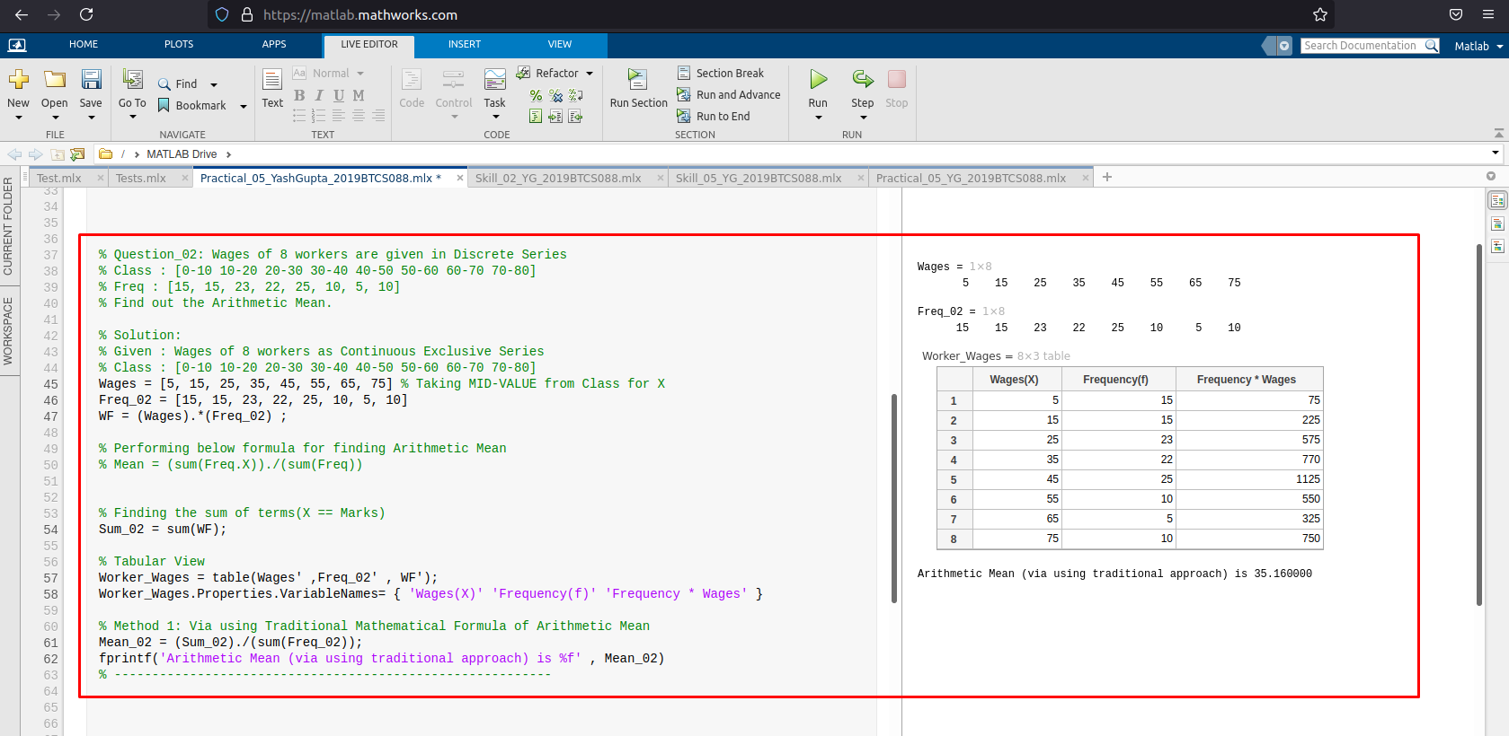

**I. Example 3: Arithmetic Mean for Continuous Series.**

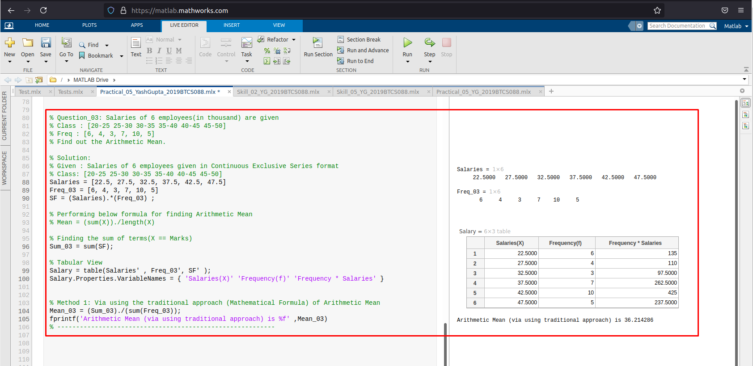

**Assessment Parameters (To be filled by faculty)**

1. **Successful completion of Practical (Y/N)**
2. **Time taken (hours/ minutes)**
3. **List other Parameters & Outcomes:**

|  |  |  |
| --- | --- | --- |
| **S.No.** | **Parameters** | **Outcomes**  **(Achieved / Not Achieved)** |
|  |  |  |
|  |  |  |
|  |  |  |
|  |  |  |
|  |  |  |
|  |  |  |
|  |  |  |
|  |  |  |
|  |  |  |
|  |  |  |

**Remarks:**

**Total marks __________ out of 10. Sign of Faculty**